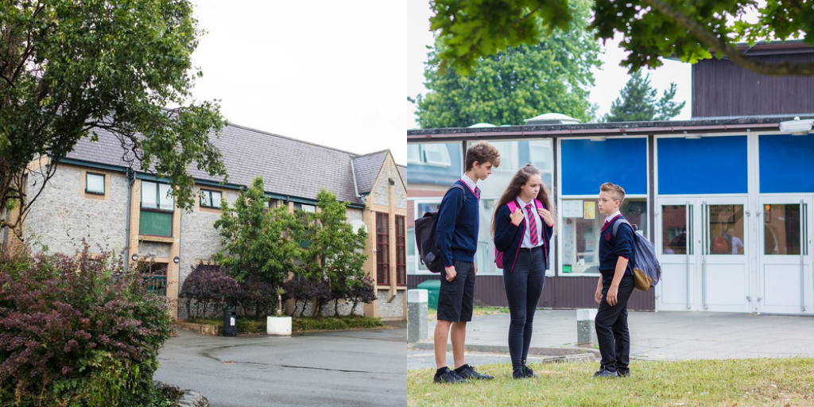

Third Party Aggression and Unacceptable Behaviours

Date Adopted | April 2022
Signature of Headteacher | 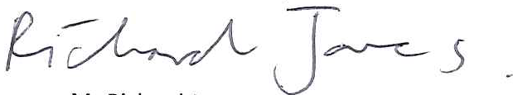
Signature of Chair of Governors
Review Date | April 2024

Builth Wells Campus  College Rd, Builth Wells, Powys, LD2 3BW  Tel: 01982 553 292 | Llandrindod Wells Campus  Dyffryn Rd, Llandrindod Wells, Powys, LD1 6AW  Tel: 01597 822 992
www.ysgolcalon.cymru

Definitions

‘Third party’ refers to any individual who is external to the school. Third-party individuals may include:

- Parents/carers/other family members of pupils
- Members of the public
- Contractors
- Work experience students

Purpose

Our ethos is to actively encourage close links with parents and the community. We believe that pupils benefit when the relationship between school and family/other relatives is a positive one. The vast majority of parents, carers and others visiting us are keen to work with us and are extremely supportive. However, on the rare occasions when a negative attitude is expressed, this can result in aggression, verbal and or physical abuse towards particular members of staff or school staff in general.

We expect our members of staff to behave professionally in these difficult situations and attempt to diffuse the situation where possible, seeking the involvement of other colleagues when appropriate. However, all members of staff have the right to work without fear of harassment, violence and abuse, both verbal and physical. We expect parents, carers and other visitors to behave in a reasonable way towards them. This policy outlines the steps that will be taken where third-party behaviour is unacceptable.

Policy

Types of behaviour that are considered unacceptable and will not be tolerated are:

- Habitual callers
- Vexatious callers
- Persons demanding disproportionate use of staff time and resources (in person, by telephone and /or by email)
- Persons shouting at members of staff, parents or children either in person or over the telephone
- Persons physically intimidating a member of staff, parent or child (e.g. by standing very close)
- Persons displaying threatening behaviour
- Persons swearing and using abusive/offensive language
- Persons displaying any kind of physical aggression
- Persons using racist, sexist, homophobic or transphobic comments

This is not an exhaustive list but seeks to provide illustrations of such behaviour. Unacceptable behaviour may result in the local authority and the police being informed of the incident.

It should be acknowledged by all staff that parents or carers may, from time to time, become anxious, stressed or upset regarding the care and/or education of their child and this may in turn lead to unacceptable behaviours. However, it must be noted that any act of aggression, violence or intimidation, both physical and non-physical, actual or threatened, from any third party, remains unacceptable.

We are committed to maintaining a culture and environment in which staff can carry out their duties without any aggressive and vexatious behaviour from third parties. Ysgol Calon Cymru is committed to providing a working environment where all staff feel comfortable and where everyone is treated with respect and dignity, regardless of gender, sexual orientation, transgender status, marital or family status, colour, race, nationality, ethnic or national origins, creed, culture, religion or belief, age, disability or any other personal factor or quality. These are known as protected characteristics. Equally, we treat all external parties with the same respect.

Third-party aggression/unacceptable behaviour/s may include any behaviour/s which is deemed to be abusive, offensive, malicious, intimidating or insulting behaviour and which may make the recipient feel upset, threatened, humiliated, harassed or vulnerable. Such behaviours may result in any of the following:

- Emotional implications such as extreme fear, anxiety
- Work-related stress
- Application of first aid
- Requirement of medical assistance
- Requirement of counselling to support their own mental health and well being
- Attendance of police or other external agencies

Procedures

If staff receive unacceptable behaviour either in person or via communication such as a phone call or email, they should:

- On the telephone: state that the tone of the conversation is making them feel very uncomfortable and that if it continues they will be ending the call, pointing out the conduct is both unacceptable and inappropriate and is interfering with the working environment.
- If an abusive email is received this should be forwarded directly to the Head Teacher who will advise the member of staff how best to respond or, if the member of staff does not wish to respond, the Head Teacher may do so on their behalf.
- If a visitor to the location exhibits any aggressive or vexatious behaviour towards staff or individuals within the location, the Head Teacher or appropriate member of the Senior Leadership Team (SLT) should be informed and the visitor will be asked to stop the behaviour or they will be asked to leave the site. If the visitor continues to behave in a way that is deemed inappropriate or the visitor fails to leave the site, the school will contact the police to ask for assistance as the safety of staff and individuals within the school remains paramount.
- A chronology of action taken by the member of staff and the Head Teacher/member of SLT should be recorded to ensure that the school keeps a full and factual account of events.
- The Head Teacher will follow this with a formal letter to the person who has displayed the unacceptable behaviour as well as the funding local authority and/or social care if there is any involvement with the family. The letter should clearly state that the behaviour was unacceptable and outline expectations re: acceptable behaviours along with next steps should this behaviour occur again.
- A judgement may need to be made as to whether a safeguarding report is required (if the event involved children)

Reparation

Following any unacceptable behaviour the school would need to determine if reparation is possible and appropriate. Considerations may include:

- A risk assessment which would provide clear expectations re: future interactions with/for this visitor
- Hosting a meeting to include: the Head Teacher, the aggressor, representative from children’s services, representative from the LA and any additional/pertinent family members

Safety

However, in extreme circumstances or where the school is dealing with repeating behaviours, a ban from school site and from contact with the member of staff who was subject to the unacceptable behaviour, may be considered and any further correspondence would be through a mediating third party to avoid further distress being caused.

