How to access school email
and download Microsoft Office for Free

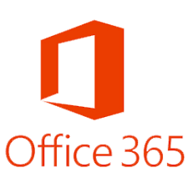
- Go to ysgolcalon.cymru and click on the link on the homepage

- Sign in using your school username for example 19joe.bloggs followed by @caloncymru.powys.sch.uk
19joe.bloggs@caloncymru.powys.sch.uk
- Your password is the same password that you use to sign into the school computers.

You may then be asked to enter a mobile number to receive a code directly from Microsoft. This is for security purposes and to verify you.

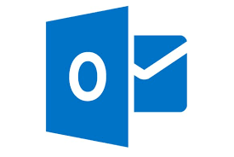
- Click on the to access your emails.

To download Office onto your home computer for free click on the logo.
This will give you free access to Word, Powerpoint, Excel and other Microsoft programmes for free at home.

