Handwriting
Practice
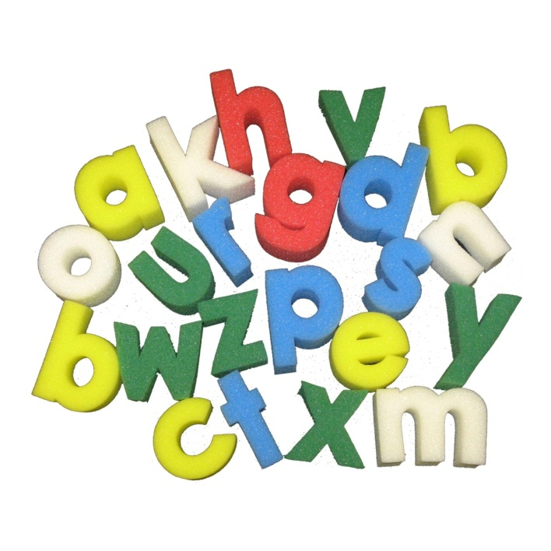
Booklet

Name: ___________________________________

Reg: ______________________________
Tutor: ____________________________________
Handwriting Practice

a b c d e f g h i j k l m
n o p q r s t u v w x y z

A B C D E F G H I J K L M
N O P Q R S T U V W X Y Z

Writing is one of the most important ways of communicating with other people. It is important then that your writing can easily be read by others.

There are just a few simple rules that you should follow to make your writing easier to read:
- Letters must be formed correctly
- good not good

- Letters should be the same height
- beautiful not beautiful

- All letters should slope the same way
- tall not tall

- Letters and words should be spaced correctly.
DO not space out letters too far
- people not people

- Between words you should leave enough space to fit a letter o
- Once upon a time
not
Onceupon atime

Your handwriting is very individual and unique to you; you don’t have to change it…. Just improve it!

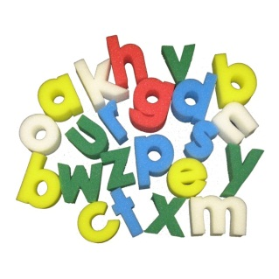
Most people use different styles of handwriting for different purposes…

- Quick notes, e.g. shopping lists
- Work in your exercise-book
- Important letters

a). Make a rapid list of things you need to bring for a cookery lesson:

b). Write the heading for a piece of school work. Give your name, the subject and todays date

c). Begin a letter to your local newsagent who is seeking “a keen boy or girl to do a morning paper-round”.

Patterns

Now, before we start to think about forming letters, let’s look at some useful patterns that will help to relax your hand and make your writing flow more smoothly.
cccc cccc cccc cccc
Copy this pattern carefully. Try to relax your hand as you write. This pattern will help when your write the letters: c a d g q o e
____________________________________________________________________________________________________________________________________________________________________________________________________________________________________________________________________________

Now try these:
c_________________________________________________________________c
a________________________________________________________________ad________________________________________________________________d
g_________________________________________________________________g
q________________________________________________________________q
o________________________________________________________________o
e________________________________________________________________e

oooo oooo oooo oooo
Copy this pattern carefully. Try to relax your hand as you write. This pattern will help when you write the letter o and join it to other letters.
____________________________________________________________________________________________________________________________________________________________________________________________________________________________________________________________________________
Now try these:
oa_____________________________________________________________oa
oo_____________________________________________________________oo
on_____________________________________________________________on
og______________________________________________________________og
od_____________________________________________________________od
op_____________________________________________________________op
hm hm hm hm hm hm
Copy this pattern carefully. Try to relax your hand as your write. This pattern will help when you write the letters: h b k
____________________________________________________________________________________________________________________________________________________________________________________________________________________________________________________________________________
Now try these:
h_______________________________________________________________h
b_______________________________________________________________b
k_______________________________________________________________k

uw uw uw uw uw
wy wy wy wy wy
Copy these patterns carefully. Try to relax your hand as you write. These patterns will help when you write the letters: i u y j
uw__________________________________________________________________________________________________________________________________
wy__________________________________________________________________________________________________________________________________

Now try these:
i_________________________________________________________________i
u_______________________________________________________________u
y________________________________________________________________y
j_________________________________________________________________j

mm mm mm mm mm
rmm rmm rmm rmm rmm
Copy these patterns carefully. Try to relax your hand as you write. These patterns will help when you write the letters: r n m p
mm_________________________________________________________________________________________________________________________________
rmm________________________________________________________________________________________________________________________________
Now try these letters:
r_________________________________________________________________r
n________________________________________________________________n
m______________________________________________________________m
p_______________________________________________________________p

Uu Uu Uu Uu Uu
il il il il il
Copy these patterns carefully. Try to relax your hand as you write. These patterns will help when you write the letters: i u l t
Uu ______________________________________________________________
___________________________________________________________________
il ________________________________________________________________
___________________________________________________________________
Now try these letters:
i_________________________________________________________________i
u_______________________________________________________________u
l________________________________________________________________l
t_________________________________________________________________t

WW WW WW WW WW
//// //// //// //// ///
Copy these patterns carefully. Try to relax your hand as your write. These patterns will help when you write the letters: V W X Z
WW_________________________________________________________________________________________________________________________________
////_________________________________________________________________________________________________________________________________
Now try these letters:
V________________________________________________________________V
W______________________________________________________________W
X________________________________________________________________X
Z_______________________________________________________________Z

//// //// //// //// ////
These are parallel down strokes. Copy these patterns carefully. This will help you to keep the slopes of your letter even.
____________________________________________________________________________________________________________________________________________________________________________________________________________________________________________________________________________
Now try these letters:
i_________________________________________________________________i
l_________________________________________________________________l
h_______________________________________________________________h
t_________________________________________________________________t
b________________________________________________________________b
f_________________________________________________________________f

Letters
Look closely at the way individual letters are formed. Check that you always start in the correct place. All letters start at the top, except d and e. Practise each letter in this order:
- Write three letters
- Check which is the best
- Write another three
- Check again
- Now practise some more

Follow the direction of the arrows with your pencil to get used to the movement of the letter, and then practise each one.

Joining
When you are sure of the correct way to form your letters and have practised the patterns to relax your hand, you will want to begin joining your letters.
There are two types of joins…….
Some letters join diagonally: city
Other letters join horizontally: food
Some points to remember:
- Take care when you join a letter to a c d g q o s
Remember: these are reversing letter. First make the joining stroke, then reverse to start the letter:
have ice bad age equal list hop

- The letters which follow b g j p q s y z need not to be joined:
ball get post quiz

- The letter s & f may be written in different ways

- The letter t joins to other letters in two ways:
diagonal: th
horizontal: tw

The following words have Horizontal Joins. Write the word, check and write I again. Do this several times and then choose the best.
to____________________________________________________________________________________________________________________________________
from________________________________________________________________________________________________________________________________
room________________________________________________________________________________________________________________________________
two__________________________________________________________________________________________________________________________________
fox__________________________________________________________________________________________________________________________________
vote_________________________________________________________________________________________________________________________________
rose_________________________________________________________________________________________________________________________________
The following words have Diagonal Joins. Write the word, check, and write it again. Do this several times and then choose the best:
it____________________________________________________________________________________________________________________________________hide________________________________________________________________________________________________________________________________
came________________________________________________________________________________________________________________________________
chain______________________________________________________________________________________________________________________________
mum_______________________________________________________________________________________________________________________________
that_________________________________________________________________________________________________________________________________
dig__________________________________________________________________________________________________________________________________
has__________________________________________________________________________________________________________________________________

The following words have Unjoined letters in them. Write the word, check, and write it again. Do this several times and then choose the best:
gap__________________________________________________________________________________________________________________________________jug__________________________________________________________________________________________________________________________________you_________________________________________________________________________________________________________________________________
zero_________________________________________________________________________________________________________________________________
jump________________________________________________________________________________________________________________________________
jim__________________________________________________________________________________________________________________________________
rest__________________________________________________________________________________________________________________________________

Activity
Section

Riding
Read the following paragraph and copy it out:
Millions of young people all round the world enjoy riding. There is a lot more to riding that just getting up and doing it. Caring for your pony is very important. A pony needs to be well fed and watered. It also needs daily attention and grooming. A happy willing pony will be the reward for all your hard work.
________________________________________________________________________________________________________________________________________________________________________________________________________________________________________________________________________________________________________________________________________________________________________________________________________________________________________________________________________________________________________________________________________________________

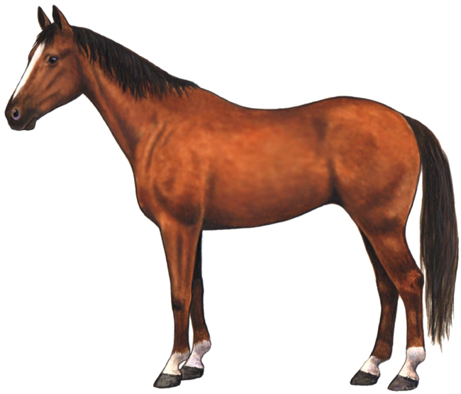
Copy each word:
saddle
_______________________________
grooming
_______________________________
bridle
_______________________________
girth
_______________________________
stirrups
_______________________________
reins
_______________________________

The Olympic Games
Read this account and copy it:
The Olympic Games began 2000 years ago in Greece. The modern Olympics started in 1896 and are held every four years. The next Olympics will be held in London in 2012 and the world’s athletes will take part in many events. The Olympic flag consists of five rings which represent the five continents.
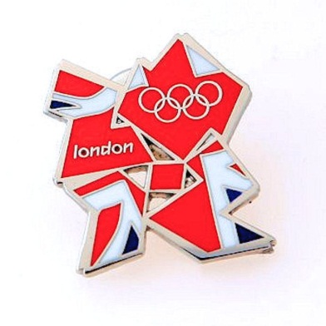
________________________________________________________________________________________________________________________________________________________________________________________________________________________________________________________________________________________________________________________________________________________________________________________________________________________________________________________________________________________________________________________________________________________

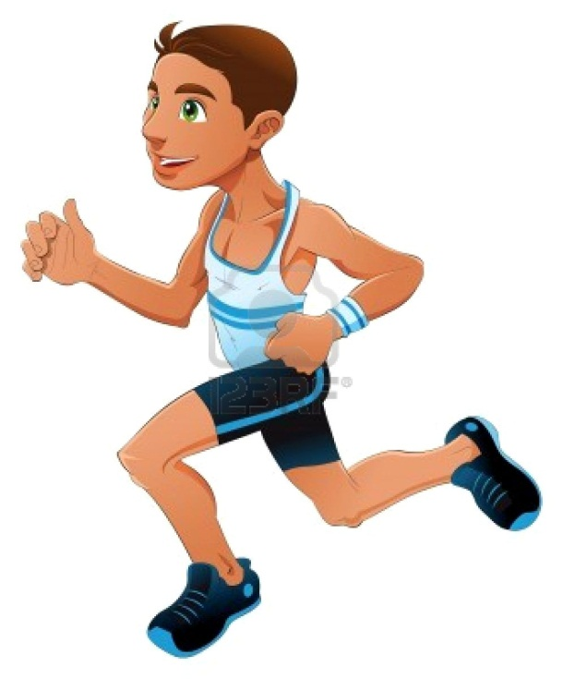
sports
_______________________________
record
_______________________________
courage
_______________________________
skill
_______________________________
speed
_______________________________
winner
_______________________________

Using the Olympic Flag below, find information on the London Olympics and write it in the circles.
Remember to use your best handwriting at all times.

Filling in a Form
Block capital letters are usually required for the completion of official forms.
Complete the form below using block capitals.
SURNAME
FORENAME(S)
TITLE: (Mr/Mrs/Miss/Master)
ADDRESS

TOWN
COUNTY & POSTCODE

Writing a personal letters
Mr. Peter Evans
Home Farm
Lower Longwood
SY5 6RC
4th September 2011

Dear Pete,
How are things? I see that Manchester United lost their last few games! I have missed the last few matches – too busy with my Geography studies.
The London trip on Saturday is supposed to get us there by 11:30 am. Please try to be in Trafalgar Square near the National Gallery and don’t forget our tickets for the Olympics! See you soon,
All the best,
Jon

Here are two envelopes to address:
Remember your writing needs to be neat in order for the letter to arrive at the correct address.
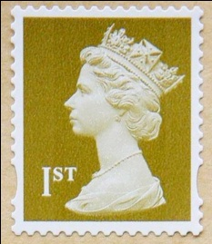

Address this one to yourself and another to Peter.

You may come across the following words many times in your SCIENCE lesson. Copy each word several times.
pressure____________________________________________________________________________________________________________________________
thermometer______________________________________________________________________________________________________________________
molecule___________________________________________________________________________________________________________________________
oxygen_____________________________________________________________________________________________________________________________
solution____________________________________________________________________________________________________________________________
chemical__________________________________________________________________________________________________________________________
electricity_________________________________________________________________________________________________________________________
particle____________________________________________________________________________________________________________________________
You may come across the following words many times in your GEOGRAPHY lesson. Copy each word several times.
equator____________________________________________________________________________________________________________________________
irrigation_________________________________________________________________________________________________________________________
antarctic___________________________________________________________________________________________________________________________
stalagmite_________________________________________________________________________________________________________________________
conurbation______________________________________________________________________________________________________________________
resources___________________________________________________________________________________________________________________________
longitude__________________________________________________________________________________________________________________________
latitude____________________________________________________________________________________________________________________________

You may come across the following words many times in your HISTORY lesson. Copy each word several times.
soilder_____________________________________________________________________________________________________________________________
knight______________________________________________________________________________________________________________________________
defeat______________________________________________________________________________________________________________________________
castle_______________________________________________________________________________________________________________________________
shield______________________________________________________________________________________________________________________________
medieval__________________________________________________________________________________________________________________________
manor______________________________________________________________________________________________________________________________
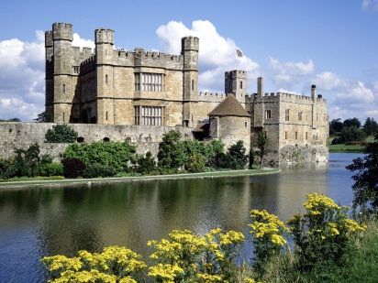
invasion___________________________________________________________________________________________________________________________

You may come across the following words many times in your MATHS lesson. Copy each word several times.
metre_______________________________________________________________________________________________________________________________
coordinate_________________________________________________________________________________________________________________________
multiply___________________________________________________________________________________________________________________________
equation___________________________________________________________________________________________________________________________
addition___________________________________________________________________________________________________________________________
parallel____________________________________________________________________________________________________________________________
triangular_________________________________________________________________________________________________________________________
percentage_________________________________________________________________________________________________________________________

