THE SCHOOL AT THE HEART OF WALES

Date adopted | June 2022
Signature of Headteacher | 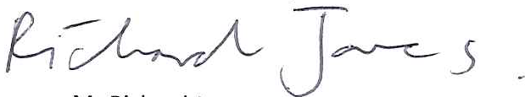
Signature of chair of governors
Review Date | June 2023

Acceptable Use Policy for Ysgol Calon Cymru

Rules governing use of E-mail

Pupils shall not:

- use racist, sexist or otherwise offensive or threatening language in the sending of e-mail messages.
- attempt to impersonate other e-mail users.

Rules governing use of the Internet

Pupils shall not:

- Attempt to access any undesirable materials such as pornography or materials of a racist or sexist nature.
- - - - - - - - - - - - - - - - - - - - - - - - - - - - - - - - - - - - - - - - - - - - - - - - - - - - - - - - - - -

Parent Consent form

Please complete and return this form to the Headteacher, ................ School.

- I am the parent or carer of ----------------------------------------------------------

- I understand that the school will take all reasonable steps to ensure that my child uses the school’s Internet and electronic mail services for appropriate purposes.

- I understand that no filtering system can guarantee to be 100% effective all the time and that there may be occasional instances of misuse by some pupils.

- I understand that my child will be held accountable for his / her use of the Internet and electronic mail services and that deliberate misuse will be treated as a serious breach of school rules and reported to me.

- I give my permission for my child to use the Internet and electronic mail services in the school.

Signed: ------------------------------------------ Date:-------------------------------
Pupil Consent form

As a school user of the Internet, I agree to comply with the school rules on its use. I will use the Internet in a responsible way and observe all the restrictions explained to me by the school.

Pupil signature:--------------------------------- Date:-------------------------------

