powys county council

education services

**Dyslexia Guidance**

**An Assessment through Teaching Approach for the Identification of Dyslexia**

December 2020

**Acknowledgments**

Many thanks to all the members of the Powys Educational Psychology and School Services who have been involved in the development of this guidance. Credit to the work of the Welsh Government, other local authorities in the UK especially Cambridgeshire, Birmingham and the Scottish Government.

Perhaps the key to our success will be found in this Welsh Proverb:

Let us start with this view of dyslexia collated from various children and young people. It is a letter to us all.

*“Having dyslexia can be hard, and at times we feel embarrassed and sad. Please make sure you highlight the things that we are doing well, and you explain to others that having dyslexia does not mean you are stupid. You know that people with dyslexia need to work harder than others to write and spell and read, but do not assume we are all the same. We struggle in different ways so please make sure you find out what our strengths and difficulties are and differentiate work for us according to our needs.*

*We may have amazing ideas but cannot get them down on paper. Help us to find another way of sharing our ideas with you and our peers. Offer lessons where we can work with others, this helps us get our ideas across without having to write them down. If we are seated near a friend, we can ask them for help, we may not feel comfortable asking students we do not know well.*

*Not all of us with dyslexia see it as a disadvantage and some of us have strengths in other areas; some are better at art than our friends without dyslexia. Some of us have good creative ideas; we have noticed that peers without dyslexia do not have ideas as ‘out of the blue’ as some of us. We may be more visual than other people and good at seeing things from a different viewpoint. Just remember that we are all different and everyone’s strengths are different.*

*When we are in your lesson, please ask us what help we would like (subtly!), we may not want the support of a Teaching Assistant, especially as we get older, and would prefer to try things on our own first. Do not make us read in front of the class, in fact do not make anyone feel they have to read in class, and please do not read out our test scores so everyone can hear. I do not want everyone to know what I got.*

*If we struggle to write quickly please help us by sending homework via email or sharing the power points from class with me. We may need extra time to complete work as some tasks take us longer to finish, do not punish us for this, show that you understand and give us time.*

*Nobody likes to be labelled so please see us as who we are and not just as our dyslexia.*

*Yours sincerely,*

*A student with dyslexia”*

**Contents**

Acknowledgements Page 1

Introduction Page 4

What is dyslexia? Page 6

The role of schools Page 11

Great teaching and dyslexia friendly practice Page 12

Information for parents/carers Page 14

Assessment for dyslexia Page 15

Screening tests Page 15

Assessment through teaching Page 15

Assessment through teaching pathway for the identification of dyslexia Page 16

Appendix 1: Self-evaluation/audit tool Page 21

Appendix 2: Information for parents Page 24

Appendix 3 & 3a: Examples of appropriate interventions and questions to consider Page 29

Appendix 4: Access arrangements Page 33

Appendix 5 & 6: Parent/carer views questionnaire and consent Page 34

Appendix 7: Child/young person’s views questionnaire Page 36

Appendix 8: Evidence checklist for dyslexia identification request Page 38

Appendix 9: Staff development Page 39

Appendix 10: Apps to support staff literacy difficulties Page 40

Help at a Glance Page 48

**Introduction**

The purpose of this document is to outline Powys’s approach to identifying dyslexia and how to meet the needs of children and young people with dyslexia. It aims to:

* promote a shared and coherent rationale and understanding of dyslexia
* adopt a common approach to the identification and provision for pupils with dyslexia using a ‘pathway’
* clarify the roles and responsibilities of all concerned, whilst promoting the active participation of children/young people and their parents/carers in the learning process
* clarify terminology and use the term ‘dyslexia’ with confidence
* share current perspectives and definitions of dyslexia
* signpost sources of information
* provide advice on classroom strategies
* advise on adapting classroom practice, approaches and access strategies, appropriate interventions and ‘dyslexia friendly’ learning environments

The intended audience is all those who work with and support children and young people including parents/carers, governors, support services, other professionals and the children and young people themselves.

This document builds on the original Powys Dyslexia Pathway and has been compiled following a review of literature and current research, considering national initiatives and guidance, and recognising good practice from other Local Authorities (LAs). Regard is given to the Equalities Act 2010 and to the statutory ALN Code (to be finalised 2021).

Welsh Government published:

A benchmarking study *Current literacy and dyslexia provision in Wales* (Research document 059) in August 2012, and then three guidance documents in the summer 2015, including:

*Specific Learning Difficulties (SpLD) Framework* (Document 175) in July 2015. The key aims of the SpLD Framework are to:

* improve the understanding of SpLD and highlight SpLD-friendly practice
* raise awareness of strategies to support school-aged children with SpLD
* encourage use of guidance and information available to schools aimed at helping support learners with a SpLD.

The key features of the SpLD Framework include:

* 16 expectation statements that provide the key characteristics of a SpLD-friendly school
* expectation statements that give a notional process for the creation of SpLD-friendly environments.

The process involves:

* **schools** ensuring that their policies support learners with a SpLD
* **learners** becoming more involved with their learning
* **practitioners** identifying, supporting, and implementing targeted interventions for learners ‘at risk’ of falling behind their peers.

The principles within this guidance are as relevant to dyslexia as they are to other types of Additional Learning Needs (ALN) and include:

* the involvement of children and young people
* a focus on raising attainment
* facilitating the LA’s commitment to raising the level of expectations/attainment for all pupils with ALN
* the importance of equality of opportunity
* early identification and intervention
* working in partnership with parents/carers

**What is dyslexia?**

The ALN Code states that “specific learning difficulties (SpLD) affect one or more specific aspects of learning”. This is an umbrella term used to describe a variety of learning differences. These include dyslexia, dyspraxia, and dyscalculia.

The term dyslexia is derived from two Greek words, ‘dys’ meaning ‘difficulty’ and ‘lexia’ from the root ‘lexis’ meaning ‘words or language’. The literal meaning is therefore ‘difficulty with words.

Despite considerable scientific and educational research, a wide variety of terminology and definitions of dyslexia remain. Worldwide there is no single, commonly accepted definition or an agreed cause.

**Recent Research**

Recent research points to expert views largely agreeing on the following points:

1. The discrepancy model is discredited:

Practitioners should:

“…shift the focus of their clinical activities away from emphasis on psychometric assessment to detect cognitive and biological causes of a child’s reading difficulties for purposes of categorical labelling in favour of assessment that would eventuate in educational and remedial activities tailored to the child’s individual needs”

(Vellutino et al., 2004)

* One of the biggest myths associated with dyslexia is that it should be defined in relation to intelligence (Elliot and Grigorenko, 2014).
* The so called ‘discrepancy definition’ of dyslexia recognises as genuine dyslexics only those whose level of reading is significantly worse than would be expected based on their intelligence (typically measured by an IQ test). Research over the past twenty years has demonstrated the folly of this belief. Puzzlingly, while the discrepancy model has been discredited (and is no longer advocated by dyslexia lobby groups), it is still widely employed by clinicians (Elliot and Grigorenko, 2014)

1. The importance of phonological skills:

* Phonemic awareness is the strongest predictor of children’s word reading skills (Elliott and Grigorenko, 2014).
* At the present time, the phonological deficit hypothesis provides the only clear-cut evidence of causal links with reading failure (Snowling, 2006).

1. Identification should be carefully considered:

* It is important for children to have sufficient experiences of literacy-based activities and interventions prior to an identification of dyslexia being sought. Children who have not had sufficient experiences could present as being dyslexic, when in fact they have simply not had enough exposure to first quality teaching (Catts, Petscher, Schatschneider, Bridges and Mendoza, 2009).

It is better to delay the identification process until a more accurate assessment can be made following a period of High-Quality Teaching (Fletcher et al, 2002; Hurford, Potter and Hart, 2002).

Very recently the **Great Teaching Toolkit (2020)** (https://www.teachertoolkit.co.uk) has been introduced in the UK with these over-arching dimensions for teachers to:

1. understand the content they are teaching and how it is learnt
2. create a supportive environment for learning
3. manage the classroom to maximise the opportunity to learn
4. present content, activities and interactions that activate their students’ thinking

We strongly recommend teachers to adopt this Great Teaching Toolkit (2020) as the newly revised curriculum in Wales is introduced in 2021. There are key messages within the toolkit for teachers about the inclusion of pupils with Additional Learning Needs, noting that great teaching is defined by its impact.

1. Specialist support helps pupils progress, regardless of the cause of reading delay:

* Differentiation of intervention based upon whether an identification has been made or not is not essential (Elliott and Grigorenko, 2014).
* Whilst an identification of dyslexia should not be made too early, it is critical that difficulties in learning to read are identified as early as possible and that targeted support is given, regardless of the cause (Torgesen, Foorman and Wagner, 2010).
* It is not useful, from an educational point of view to differentiate between the dyslexic and other poor readers as the techniques used to teach both dyslexic and other struggling readers are the same (UK Commons Science and Technology Committee, 2009).

“Where a pupil continues to make less than expected progress, despite evidence-based support and interventions that are matched to the pupil’s area of need, the school should consider involving specialists including those secured by the school itself or from outside agencies” (ALN Code)

“A school should always involve a specialist where a pupil continues to make little or no progress or where they continue to work at levels substantially below those expected of pupils of a similar age, despite evidence-based SEN support delivered by appropriately trained staff.” (ALN Code)

1. It is helpful to check that:

* Any co-occurring difficulties have been identified, to ensure that the intervention planned can take these into account (Sumner et al., 2009; Sexton et al.,2012)
* The pupil’s word reading, and spelling skills are both accurate and fluent (Rose, 2009; Elliot and Grigorenko, 2014).

“It is important to differentiate between children who have decoding difficulties and those who, while accurate and fluent readers, struggle with other reading-related problems such spelling and comprehension.” (Elliott and Grigorenko, 2014, p 161)

**Relevant Definitions**

Both the British Psychological Society (1999) and the comprehensive report provided by Jim Rose (2009) provide useful definitions.

These definitions are as follows:

**British Psychological Society (BPS)**

*Dyslexia is evident when accurate and fluent word reading and/or spelling develops very incompletely or with great difficulty. This focuses on literacy learning at the ‘word level’ and implies that the problem is severe and persistent despite appropriate learning opportunities. It provides the basis for a staged process of assessment through teaching.*

**Rose Report Definition**

*Dyslexia is a learning difficulty that primarily affects the skills involved in accurate and fluent word reading and spelling.*

Rose also indicates professional agreement around the following:

1. Characteristic features of dyslexia are difficulties in phonological awareness, verbal memory, and verbal processing speed.
2. Dyslexia occurs across the range of intellectual abilities.
3. Dyslexia is best thought of as a continuum, not a distinct category, and there are no clear cut off points.
4. Co-occurring difficulties may be seen in aspects of language, motor coordination, mental calculation, Executive functioning (EF) but these are not, by themselves, markers of dyslexia.
5. A good indication of the severity and persistence of dyslexic difficulties can be gained by examining how the individual responds or has responded to well-founded intervention.

Recently Professor Joe Elliott, Durham University (2016) has reminded us:

*“What is clear is that we need to identify those who struggle with literacy (in its various forms – reading accuracy and fluency, spelling, and writing), and intervene effectively, as soon as is possible. It appears that* ***response to intervention*** *models, while still far from perfect, offer the best means to ensure that additional resources and attention are employed most efficaciously with those who most require them. Current approaches to dyslexia identification, diagnosis, and remediation, leave large numbers of struggling readers, often from less advantaged backgrounds, without recognition or support.*

*In intervening, we should use those approaches that have rigorous scientific support. In practice, this means that, until new approaches are supported by research, we should employ structured educational approaches, typically involving phonics teaching, within a broad and balanced literacy programme.”*

We balance this view with recommendations from Professors Margaret Snowling & Charles Hulme (2020), from the University of Oxford:

*“The term dyslexia can be properly used to describe children who experience problems learning to read and write; often when a basic level of reading and spelling ability is established, there are persisting problems with reading ﬂuency. Dyslexia is a dimensional disorder, however, with no clear cut-oﬀ from poor reading. This does not mean it is not a handicap. If diﬃculties in learning and in developing ﬂuency persist, then we would argue the term should be used, not least to signal the need for intervention. In addition, it should be recognised that assessment is needed to identify co-occurring problems; if present, these may require separate management, but they do not deﬁne dyslexia. The need to intervene is clear: children with poor reading are at elevated risk for a range of emotional and behavioural diﬃculties. Moreover, longer-term follow-up studies make clear that problems with literacy persist into adulthood, and are associated with lower levels of educational attainment, higher rates of unskilled employment, and often periods of unemployment. At the same time, since some individuals with dyslexia can compensate for their diﬃculties, dyslexia need only be disabling if the individual remains unable to cope with the literacy demands of study or work even when appropriate arrangements are in place. How dyslexia is recognised by the education system, and by society more generally, has changed over its history, and continues to evolve. ……. Despite best eﬀorts, some children will continue to ﬁnd reading diﬃcult. Optimal outcomes for these children require us to embrace the dimensional nature of dyslexia and its associated complexities; to fail to do so is negligent and arguably morally indefensible.”*

**The foundation to Powys’s identification process**

Powys has considered the most up-to-date research and the BPS and Rose report definitions to agree that dyslexia occurs at the word level in terms of either:

1. incomplete reading and/or spelling accuracy
2. incomplete accuracy and fluency in reading and/or spelling (Rose, 2009; BPS, 1999)

**Powys is also basing the identification process on the following:**

**These difficulties are persistent and severe despite appropriate learning opportunities within an assessment through teaching approach (BPS, 1999) and pupils have made less than expected progress following targeted interventions and the involvement of specialist support that has been tailored to pupils’ individual needs (ALN Code).**

For example: if a child is having a continuing difficulty with remembering spelling patterns and how to write and use them, they should have received an intervention such as *Direct Phonics*. If this was shown not to be effective other interventions will have been tried e.g., Cued Spelling. Despite this, the young person will still have severe difficulties.

**Whilst recognising that word level reading and or spelling difficulties occur across a continuum from mild to severe (Rose, 2009), Powys will focus on identifying pupils who have persistent and severe difficulties as having dyslexia.** Around 4 to 8% of the school population is estimated to have dyslexia (Butterworth & Kovas, 2013) and a similar estimate of prevalence is quoted by Snowling (2013). Powys will identify dyslexia within this range where word level difficulties continue over a period, **despite appropriate intervention at the specialist level.** Therefore, before dyslexia is considered as a possible cause for observed difficulties, it is imperative that steps have been taken and provision made to address them.

Pupils with milder reading and or spelling difficulties i.e., above the 16th percentile/Standard score 85, should continue to access support through *Great Teaching* and appropriate differentiation.

Children with complex, general learning difficulties should continue to access targeted or specialist support through a graduated approach.

**The role of schools**

Powys supports the view that children with dyslexia and other learning difficulties learn and make progress most effectively by being taught and supported in a familiar environment by their teachers and teaching assistants through *Great Teaching*.

This is reflected in a *graduated approach* which begins with *Great Teaching* and follows an ‘***assess, plan, do and review’*** process.

All teachers:

* Set suitable learning challenges
* Overcome barriers to learning
* Respond to pupils’ diverse needs

**Great teaching toolkit and dyslexia friendly practice**

There are certain teaching methods and practical approaches which are particularly effective to promote access to learning for all children, including those with dyslexia. For the most part these strategies should just be part of Great Teaching rather than being something additional. Great Teachers should convey care, empathy and warmth towards their students and avoid negative emotional behaviours, such as using sarcasm, shouting or humiliation. One aspect of teacher-student relationships that deserve specific attention is relationship with students with additional learning needs (ALN).

The requirement for respect and sensitivity towards students’ individual needs is amplified in both importance and difficulty when those needs are more diverse or extreme. Developing good relationships of trust and respect with students additional learning needs, neurodiversity or disabilities often requires specific knowledge and adaptation. Generic labels such as ALN or their subcategories cover a wide range of individual differences, and the processes by which they become attached to individual students – or may go undiagnosed – are also variable. ***Great teachers know their students well as individuals, are well informed about the nature and requirements of their students’ specific needs and have strategies to accommodate them.***

**Diagram 1: Common features of *Great Teaching* and dyslexia friendly strategies**

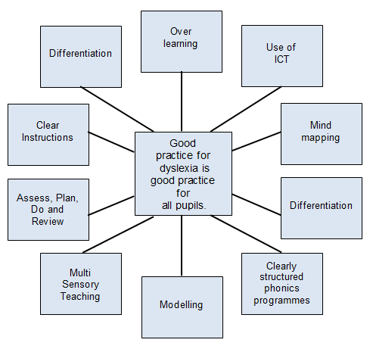

**Multisensory learning** involves using two or more senses during the learning process. For example, a teacher who provides lots of hands-on activities, such as building a 3-dimensional map enhances their lesson by allowing pupils to touch and see the concepts being taught.

Multisensory teaching is an effective approach to teaching pupils with dyslexia. In traditional teaching, pupils typically use two senses: sight and hearing. Pupils see words when reading and they hear the teacher speaking. But many with dyslexia may have problems processing visual and auditory information. By including more of the senses, making lessons come alive by incorporating touch, smell and taste into their lessons, teachers can help those with dyslexia learn and retain information. Multisensory teaching is simultaneously visual, auditory, and kinaesthetic-tactile to enhance memory and learning. Links are consistently made between the visual (what we see), auditory (what we hear), and kinaesthetic-tactile (what we feel & do) pathways in learning to read and spell.

* <https://www.youtube.com/watch?v=bIzZzbrlK9c> (BDA)
* <https://www.youtube.com/watch?v=qWBjBq73oR4> (BDA)

There is a useful section on multi-sensory approaches in the ‘Derbyshire File for Dyslexia Friendly Schools’ that was circulated several years ago and may still be available in your school.

**Information for parents/carers**

Appendix 2 contains information which schools are encouraged to share with parents/carers who might be concerned about whether their child has difficulties consistent with the definition of dyslexia. It also incorporates further information about the kind of support that is available in schools.

**Assessment of dyslexia**

It is important to note that current research clearly indicates that the identification of dyslexia does not take place through a one-off assessment. Schools within Powys identify dyslexia when difficulties at the word level are evident over time and are persistent despite universal, targeted and specialist support through the graduated approach.

**Screening Tests**

There are many different types of screening tests. Some are delivered by computer; others need to be administered by a teacher. Some claim to give an estimate as to whether the child/person is likely to have dyslexic difficulties. However, they are often based on a discrepancy model that has been widely discredited so therefore screening tests cannot identify dyslexia and should not be used as predictors because other techniques are better.

**Assessment through teaching**

Powys has an **assessment pathway** that describes the process towards a formal identification of Dyslexia. It is designed to comply with the requirements of the ALN Code and ensures that children and young people receive the support they need.



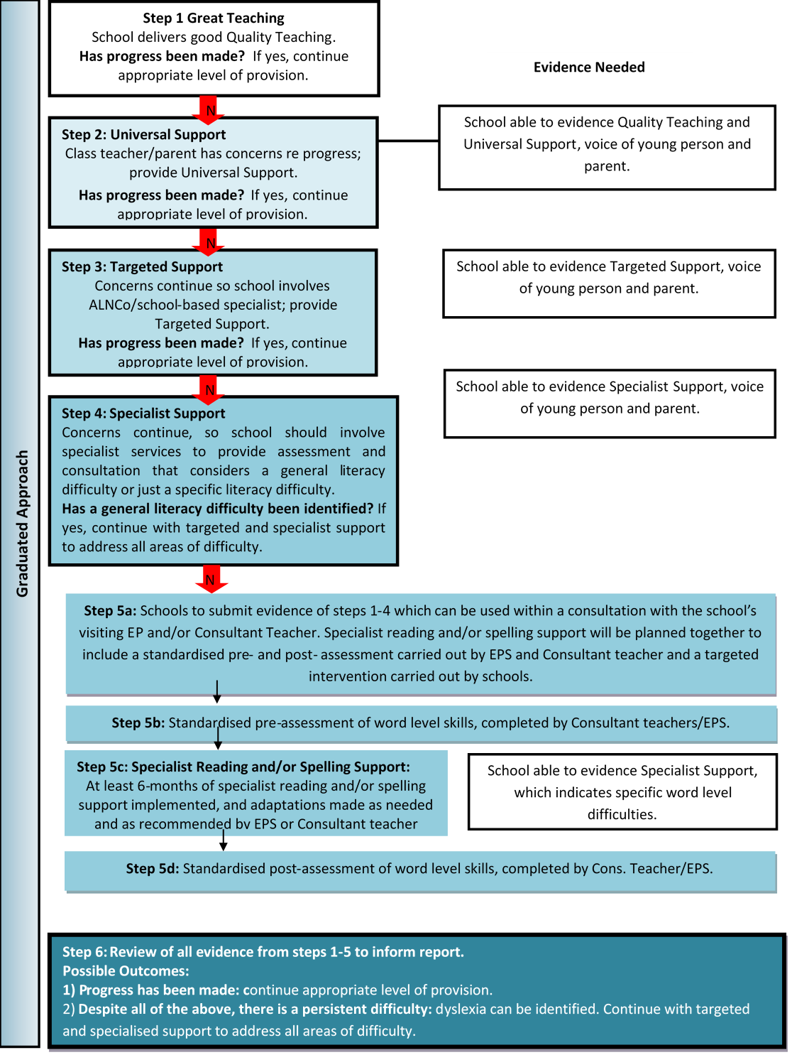

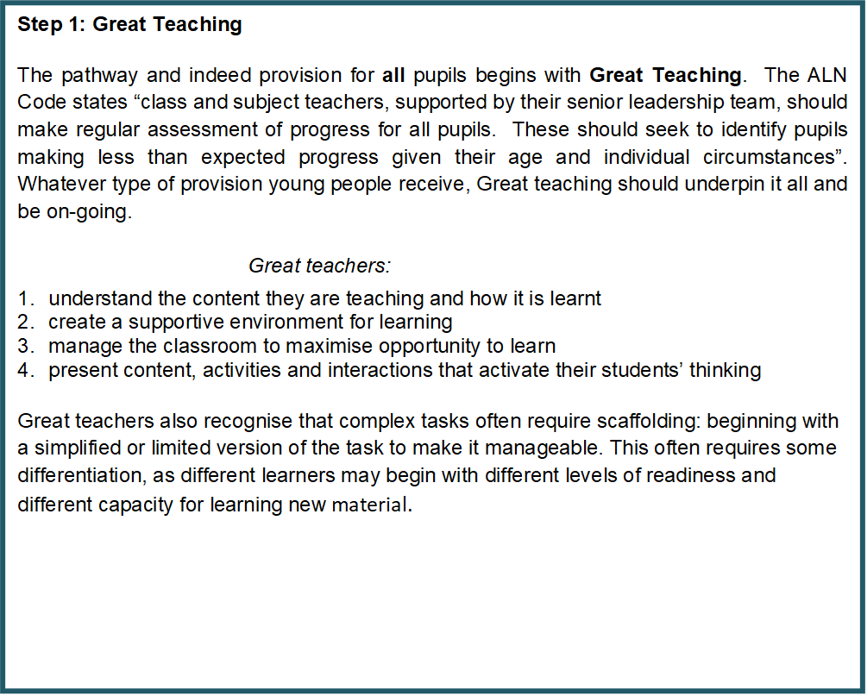

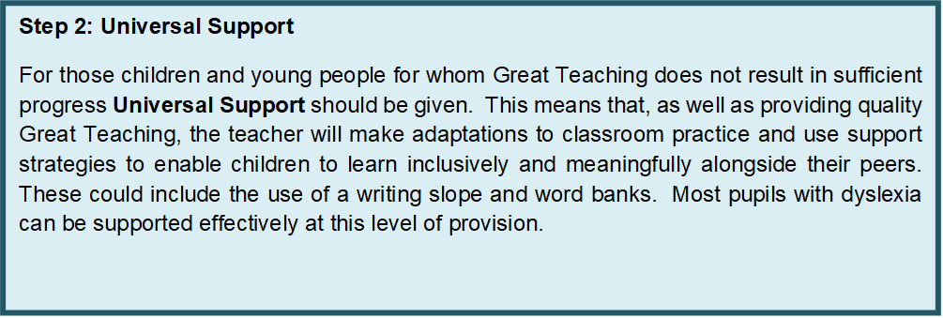

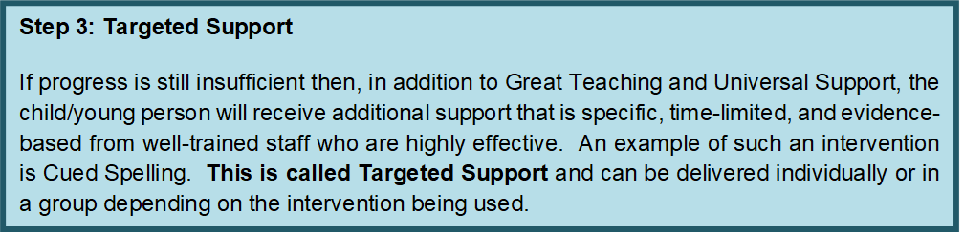

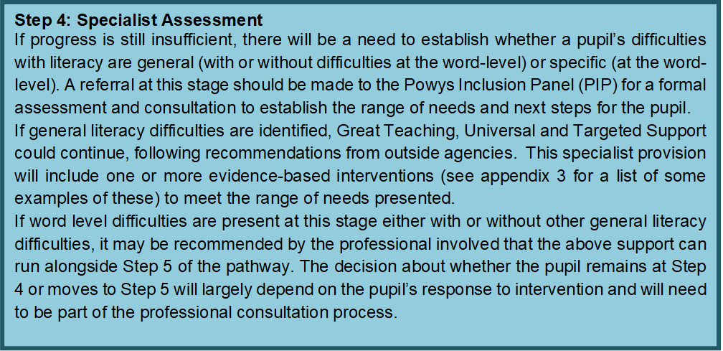

At each level of support, it is vital, as prescribed in the ALN Code, that parents are involved in the process. In addition, the views of the young person must also be sought and considered.

**Who should be considered for an identification of dyslexia (step 5)?**

1. If the evidence suggests that the child/young person has a wide range of literacy difficulties an identification of dyslexia may not be appropriate. An assessment for dyslexia should only be considered if word-level difficulties are present, following initial assessment and advice from the relevant Powys professional.
2. If evidence suggests a more specific literacy difficulty has been identified at step 4, then progress to step 5 where specialist support will include pre- and post- assessments of word level skills and targeted intervention supported by outside agencies. This will confirm if the presenting difficulties are severe and persistent in line with Powys’s definition of dyslexia.

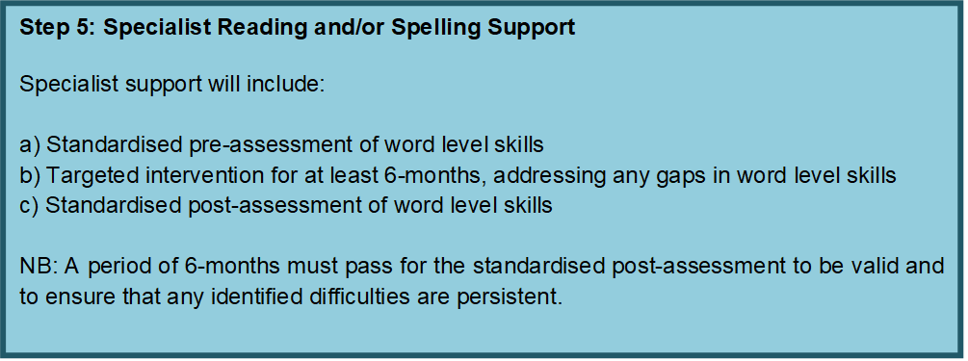

**Possible outcomes at step 6:**

If evidence collected reflects accelerated progress because of the specialist intervention programme(s), an identification of dyslexia should not be considered. This is because the difficulty will have been shown as not ‘persistent or severe, despite appropriate provision’. If this is the case, then the level of provision needed by the young person is likely to decrease or be maintained. It is unlikely to need to be increased**.**

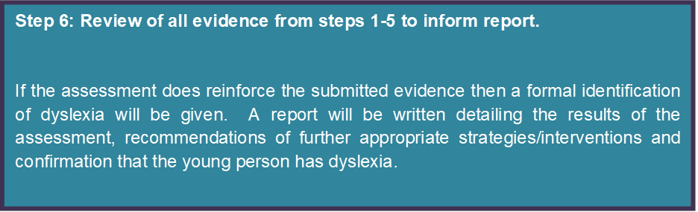

**Documents to support the process**

In the appendix you will find the following documents to support the implementation of the pathway:

* Appendix 1: Self-evaluation/audit tool
* Appendix 2: Information for parents/carers
* Appendix 3: Examples of appropriate interventions and means of assessing them
* Appendix 4: Parent/carer consent form for the identification of dyslexia
* Appendix 5: Parents’/carers views questionnaire
* Appendix 6: Child/young person’s views questionnaire
* Appendix 7: Evidence checklist for dyslexia assessment request (see separate Powys Inclusion Panel – Evidence Gathering document)

**Appendix 1: Self-evaluation/audit tool**

**Quality Teaching Checklist**

**Teacher: ____________________________ Date: _____________________**







**Appendix 2: Information for parents/carers**

Most children learn to read and write easily, others take longer and may need extra help. However, a few children find the process of learning to read and spell particularly hard and it can then become a barrier to learning. Such children may have underlying problems that, despite appropriate ‘teaching’, affect their ability to learn these skills. This can sometimes be referred to, particularly by professionals, as a ‘Specific Learning Difficulty’ (SpLD) or dyslexia.

The ALN Code, states that “specific learning difficulties (SpLD), affect one or more specific aspects of learning”. This is an umbrella term used to describe a variety of learning differences. These include dyslexia, dyspraxia, and dyscalculia.

The term dyslexia is derived from two Greek words, ‘dys’ meaning ‘difficulty’ and ‘lexia’ from the root ‘lexis’ meaning ‘words or language’. The literal meaning is therefore ‘difficulty with words.

There is no single identified underlying cause for dyslexia or one single definition. This can lead to difficulties when trying to identify it.

Despite the use of different definitions of dyslexia, expert views largely agree on two basic points:

1. It is now widely accepted that dyslexia exists.
2. Identifying dyslexia and developing ways to support dyslexic learners should be the focus of the way forward (Rose Report 2009).

Powys, in line with current thinking and research, accepts and recognises the need for both of the following definitions:

**British Psychological Society (BPS)**

Dyslexia is evident when accurate and fluent word reading and/or spelling develops very incompletely or with great difficulty. This focuses on literacy learning at the ‘word level’ and implies that the problem is severe and persistent despite appropriate learning opportunities. It provides the basis for a staged process of assessment through teaching.

**Rose Report Definition**

Dyslexia is a learning difficulty that primarily affects the skills involved in accurate and fluent word reading and spelling and in addition:

Characteristic features of dyslexia are difficulties in phonological awareness, verbal memory, and verbal processing speed. Dyslexia occurs across the range of intellectual abilities.

The above definitions recognise that, for an identification of dyslexia to be made, **the appropriate provision must first have been made.** Without this provision it would not be possible to tell whether the difficulties are ‘persistent and severe’. Therefore, when the school is requesting an assessment of dyslexia, they will be asked to submit evidence of what provision has been made to date to address the observed and assessed difficulties.

Powys has considered the most up-to-date research and the BPS and Rose report definitions to agree that dyslexia occurs at the word level in terms of either:

1. incomplete reading and/or spelling accuracy
2. incomplete accuracy and fluency in reading and/or spelling (Rose, 2009; BPS, 1999)

Powys is also basing the identification process on the following:

These difficulties are persistent and severe despite appropriate learning opportunities within an assessment through teaching approach (BPS, 1999) and pupils have made less than expected progress following targeted interventions and the involvement of specialist support that has been tailored to pupils’ individual needs (ALN Code).

However, dyslexia is not all about difficulties. Children and young people may have strengths in the following areas:

* problem solving
* music
* art
* sport
* ICT
* discussion/explanations

It helps to discover and celebrate strengths and to work with the school to develop them. It is also important to keep a child’s confidence and self-esteem high. If you feel that your child’s difficulties with reading and spelling are affecting their progress at school, this may be the time to talk to your child’s class-teacher and discuss your concerns.

**What can the school do to support my child?**

Teachers regularly assess a child’s progress to help them plan new work and identify areas of strength and any difficulties that a child may be presenting. If teachers are concerned about progress, they can look at how they can adapt their teaching and/or the environment to help the child learn; this may include making small changes to the way a lesson is taught, the materials that are used, or the support given to a child or to a group of children in some lessons.

For more detailed, specific information about what your child’s school provides see the school’s ALN Information Report. This is something that the ALN Code requires schools to publish on their websites. It is updated annually.

The levels of support given to children and young people can be defined as Universal, Targeted and Specialist.

**Universal Support**: In addition to *Great Teaching*, the class teacher will make creative adaptations to classroom practice and use support strategies to enable children to learn inclusively and meaningfully alongside their peers e.g., use of a writing slope, coloured paper, word banks and so on. Most pupils with dyslexia can be supported effectively with this level of support.

**Targeted Support**: In addition to *Great Teaching* (and probably Universal support too) the child/young person will receive additional support that is specific, time-limited, and evidence-based from well-trained staff who are highly effective. An example of such an intervention is *Cued Spelling*. Targeted support can be individual or in a group depending on the intervention being delivered.

**Specialist Support**: Great Teaching and Universal Support are likely to continue but the young person’s needs are such that they require the skills of a specialist teacher or group of professionals to be involved. Most of the pupil’s time is spent in the mainstream classroom but their ‘additional to and different from’ provision is highly personalised and very closely monitored. The class or subject teachers should be clear on how to encourage independence and boost confidence.

**Frequently asked questions for parents/carers**

**Q. Is dyslexia hereditary?**

**A.** There is substantial evidence to support the view that dyslexia is evident in generations of families (Ott, 1993). It could often skip a generation or be present in the extended family such as uncles or cousins, as well as in siblings. Another study which followed the development of children born to parents with dyslexia revealed a heightened risk of literacy impairment (Snowling & Frith, 2003).

**Q. Why use the term dyslexia instead of Specific Learning Difficulties?**

**A**. Dyslexia is one example of a Specific Learning Difficulty (other examples include dyspraxia and dyscalculia). Therefore, to make it clear what is being talked about, the term dyslexia is still being used.

**Q. Can dyslexia occur across the full range of abilities?**

**A**. Yes. Dyslexia affects children across the range of intellectual abilities (Rose Report).

**Q. How do parents get their child’s dyslexia acknowledged?**

**A**. The best place to start is in school. If parents/ carers have any worries about their child’s literacy development, they should talk to the class/form teacher and possibly the ALNCO who can share information about the different levels of identification.

**Q. Who can identify that a child has dyslexia?**

**A**. Powys prefers to use the term identification rather than diagnosis. This is because the term diagnosis implies a medical condition.

To make a formal identification of dyslexia, the assessor must hold a suitable qualification. In Powys this is any Educational Psychologist and those teachers in Schools who hold an appropriate Postgraduate Diploma. The latter are also accredited by the British Dyslexia Association and hold current AMBDA accreditation (Associate Member of the British Dyslexia Association).

**Q. What is the best test for dyslexia?**

**A**. There is no single test for dyslexia. This is because a one-off test can only ever give a snapshot of a child’s performance at a single point in time. It does not consider whether appropriate support and provision has been given to address any difficulties. This is important to be able to identify whether the difficulties are ‘persistent and severe’ (see the definitions of dyslexia above).

**Q. How does Powys assess for dyslexia?**

**A**. There is no single test for dyslexia; Powys uses the assessment through teaching approach. This involves observing and assessing how a child / young person responds to provision that is put in place by the school / setting at the universal, targeted and specialist stages as detailed in the ALN Code. Standardised tests are used to support professional judgement in identifying literacy difficulties at the word level that are severe and persistent over time.

**Q. What is specialist dyslexia teaching?**

**A**. Teaching to support dyslexia is high quality literacy teaching that addresses the needs of the individual and is usually delivered in the classroom; however, some schools may have access to a specialist dyslexia teacher who has attained accredited specialist qualifications usually at a post graduate Level.

**Q. How many children experience dyslexia?**

**A**. Around 4 to 8% of the school population is estimated to have dyslexia (Butterworth & Kovas, 2013) and a similar estimate of prevalence is quoted by Snowling (2013).

**Q. Can dyslexia occur in all ethnic groups?**

**A**. Yes. Literacy and dyslexic difficulties can be identified in males and females across languages, ethnic and socio-economic groups (Rose Report p36).

**Q. If my child is identified as having dyslexia; will this always be the case?**

**A**. Yes - Dyslexia is a persistent condition that will require ongoing appropriate strategies and intervention for any literacy-based activities.

**Appendix 3: Examples of appropriate interventions**

**This list is not meant to be exhaustive** and there may be other interventions that you have used. However, all interventions should make **additional to and different from** provision. Please also refer to Appendix 10 on **iPad apps and literacy difficulties**.

The publication ‘What Works for Children and Young People with Literacy Difficulties? ed. 4’, (Brooks 2013) provides more information as does the SpLD Trust. Links to both can be found below:

* <http://www.interventionsforliteracy.org.uk/widgets_GregBrooks/What_works_for_children_fourth_ed.pdf>
* <http://www.interventionsforliteracy.org.uk/home/interventions/list-view/>

We recommend any intervention period is:

* 12 weeks (one term); followed by review.
* Always supervised by an adult confident with the intervention (ensure fidelity)
* Delivered 1:1 or in a small group
* Interleaved with class-based work
* Delivered on a consistently regular basis

|  |  |  |
| --- | --- | --- |
| ***Name*** | ***Publisher/Further details*** | ***Comment*** |
| Acceleread | www.dyslexic.com/product/acceleread-accelewrite/ | Computer based |
| Alpha to Omega | Dyslexia Action | In use for 30 years |
| Catch Up/Dyfal Donc | www.catchup.org | Basic skills level |
| Clicker 8 | www.cricksoft.com | Writing support |
| Cued Spelling | Developed by Keith Topping, University of Dundee  https://highlandliteracy/cued-spelling | Researched at Dundee University |
| Direct Instruction | McGraw Hill |  |
| Direct Phonics | www.directphonics.co.uk |  |
| Fastforword | www.scilearn.com/ |  |
| Fresh Start  (Read, Write, Inc.) | OUP | 9-13-year olds |
| Lexia | www.lexialearning.com |  |
| NESSY | www.nessy.com |  |
| Paired Reading | https://highlandliteracy.com/paired-reading/ | Researched at University of Dundee |
| PAT – Phonological Awareness Training | www.teachphonics.co.uk/ |  |
| POPAT | http://popat.co.uk/ | Welsh version |
| Precision Teaching | http://www.johnandgwyn.co.uk | Monitoring tool |
| Peer tutoring | Developed by Keith Topping, University of Dundee |  |
| Reading Recovery | www.ucl.ac.uk/reading-recovery-europe/reading-recovery | 6-year olds  Advanced teacher qualification required. |
| Sound Linkage | Hatcher & Hulme (Wiley) |  |
| Thinking Reading | www.thinkingreading.com/ | High School |
| Toe by toe | https://toe-by-toe.co.uk/ |  |
| TRUGS | www.readsuccessfully.com | Game |
| The Word wasp | www.wordwasp.com/ | By same author as Toe by toe |
| Units of Sound | www.unitsofsound.com/ |  |
| Word shark | www.wordshark.co.uk/ |  |

**Appendix 3a: List of questions for practitioners when considering intervention approaches**

**Assessing the intervention method**

1. Is there reliable and freely available impact data acquired through objective research to verify the effectiveness of the programme in terms of accelerating improvement in skill development that you want to work on?
2. What is the evidence of effectiveness?
3. Does the intervention have a lasting impact once the intervention has ended, or does it only work while receiving it?
4. Has the intervention been developed for the specific purpose you are using it for?
5. Do you require specialist training to deliver it?
6. If it is targeting an aspect, e.g., reading, does it achieve this?
7. How are the components broken down and worked on?

**Assessing the progress of the learner using a chosen intervention**

Once you have chosen the intervention approach, consider the following.

1. Who will deliver the intervention? What skills do they need? What training do they have or need?
2. Consider if there are constraints on delivering the intervention, e.g., limited space/noisy classroom/lack of time/specific resources required to deliver it. What resources do you require?
3. How can you optimise delivery, e.g., finding a quiet setting/sufficient space/time of day, so the learner is not too tired to focus on the tasks?
4. Can you provide intervention as part of a group or does it need to be one to one?
5. Have you defined the goals for the intervention? Have you gathered them from relevant sources, e.g., parent/carer/teacher/learner?
6. Are you clear about the steps that need to be made to achieve your goals?
7. What will you use as measures of effectiveness? Will you use a repeat test? Will you look at the impact on confidence/participation/transferability into other areas? How will you do this?
8. What information/data will you measure and record to track and monitor? How and where will this be recorded?
9. How will you build-in sufficient practice in the skills you are trying to achieve at home or at school?
10. Are families/carers considered in the intervention approach to provide opportunities for practice between sessions? What information can you relay to the families/carers to help with this?
11. What is the cost to develop, buy or manage the intervention? Consider the different aspects to delivery and monitoring.

**What is progress monitoring?**

This measures each learner’s level of performance against identified goals for learning at regular intervals. Progress is measured by comparing expected and actual rates of learning. Instructional strategies are then adjusted to meet the individual learner’s learning needs.

**What is the response to intervention (RTI) model?**

The key principles relating to RTI include the following

* Intervene early.
* Use a multi-tiered system of support
* Use problem-solving processes to explore why something is working or not.
* Use assessments
* Use evidence-based instruction.
* Monitor progress.
* Use data to make decisions to act and move the learner through layers of support. This will require an ongoing data collection system.

For further information from the USA, see the RTI Action Network website at <http://www.rtinetwork.org/>

**Ratio Gain (RG)**

An effective way to establish if a reading or spelling intervention has been effective is to use ratio gains.

Many UK studies report results not in standard scores but in reading and spelling ages, from which ratio gains can be calculated to evaluate the effectiveness of the intervention.

Ratio gain is the gain in reading (or spelling) age made by a group during a chronological time span, expressed as a ratio of that time span (Topping & Lindsay, 1992).

For example:

If a child has a reading age of 7:04 years at the start of an intervention and after 10 weeks (that is 2 ½ months) he ends with a reading age of 8:00 years he has made progress of 8 months in this 2 ½ month period. On the face of this it looks very good, but how good is it? We can calculate this by finding out the ratio gain.

RG = months gain divided by time in months.

In this case it would be:

8 months___ = RG of 3.2

2 ½ months

A ratio gain of 1.0 means that the child’s skills are developing at a normal pace, **but they will not be catching up with their peers**. Brooks (2007) suggests that:

* Ratio gains of less than 1.4 are of ‘doubtful educational significance’,
* Between 1.4 and 2.0 of ‘modest impact’,
* Between 2.0 and 3.0 of ‘useful impact’,

In the case above the child’s progress has been of ‘**substantial impact’**

* Between 3.0 and 4.0 of ‘substantial impact’ and
* Above 4.0 of ‘remarkable impact’ (Brooks. 2007, p. 289).

However, Brooks (2007) points out that ordinary teaching (i.e., no intervention) does not enable children with literacy difficulties to catch up, and hence it is fair to presume that, in the absence of control or comparison groups, and where effect sizes cannot be calculated, findings of **ratio gains more than 2.0 may be taken as good evidence in support of the method employed**.

**NB**

Several studies have shown that, without help, **dyslexic pupils** progress at around only 5 months per calendar year in reading (ratio gain 0.42) and 3 months in spelling (ratio gain 0.25) (Thomson, 1990, 2001; see also Rack and Walker, 1994). It is suggested **that in cases of dyslexia the achievement of ratio gains of 1.00 or greater represents substantial progress** for these individuals, even though they may still have literacy skills below levels required to access the curriculum effectively.

**Appendix 4: Test, exam, and access arrangements**

There will be several students who, despite appropriate support and intervention, will not sufficiently develop their literacy skills to be able to demonstrate their knowledge and skills in examinations. Exam access arrangements can be hugely beneficial part of the support for students with dyslexia, however, because dyslexia is a spectrum condition learner with dyslexia do not automatically qualify.

Key principles

* Access arrangements must be based primarily on normal classroom practice
* Access arrangements should never provide an unfair advantage
* The support given must not change the exam questions
* Answers given must be the pupil’s own
* Always consult with the pupil before putting the arrangement in place

Examples of access arrangements that may assist pupils with dyslexia include:

Extra time (e.g. if speed of processing is affected)

Use of a laptop (e.g. if writing is slow or illegible)

Reader (e.g. for poor readers with difficulty decoding or understanding text).

It is important to note that exam access arrangements put in place by a primary school may not be always needed in secondary schools as needs may change over time.

The JCQ regulations can be found at <http://www.jcq.org.uk/exams-office/access-arrangements-andspecial-consideration>

**Appendix 5: Parent/carer consent form for the identification of dyslexia**

Your child has been receiving support through an ‘assessment through teaching’ approach that has been delivered in school over a period. This graduated approach follows the statutory guidance for supporting children who are experiencing difficulties in learning (ALN Code).

As part of this approach, advice has been sought from outside agencies, who have assessed your child and recommended a period of targeted intervention, followed by a reassessment.

As a school we now wish to make a referral to the Powys Inclusion Panel for a teacher with a specialist qualification in dyslexia. The teacher will review the evidence presented to establish whether your child has literacy difficulties at the word level which are ‘severe and persistent’ in line with the Powys dyslexia guidance and pathway, as a result, your child may or may not be identified as having dyslexia.

Your permission is required to enable the teacher to review the evidence and discuss your child’s learning and progress with the school ALNCO and other professionals already involved.

The teacher will keep records of their involvement and will produce a written record of the consultation. Please note this information may be shared electronically.

__________________________________________________________________________

I give permission for the Powys School Service to review and discuss evidence of the assessment through teaching approach that has been undertaken with my child.

School: _________________________

Child’s Name: _______________________________ Date of Birth: _______________

Name of parent/carer: ______________________________________

Signed: _____________________________ Date: ________________

**Appendix 6: Parent/carer’s views questionnaire**

**How Does Your Child Learn?**

**Have you noticed any specific difficulties that your child experiences in reading and spelling? What are they?**

**How long have these difficulties been present?**

**Does your child have difficulties in any other areas of learning?**

**Does your child have additional help at school? If yes, please tell us what this is.**

**What strengths does your child have in relation to their schoolwork and learning?**

**Is there anything else that you would like us to know?**

**Appendix 7: Child/young person’s views questionnaire (Step 5)**

**How do you learn?**

Tick next to the face that shows how you feel:



**1. How confident do you feel about reading in front of your class/group?**

**☹**

0

**☺**

0 1 2 3 4 5 6 7 8 9 10

**2. How happy are you with your reading?**

**☹**

0

**☺**

0 1 2 3 4 5 6 7 8 9 10

**3. How much do you enjoy reading?**

**☹**

0

**☺**

0 1 2 3 4 5 6 7 8 9 10

**4. How happy are you with your spelling?**

**☹**

0

**☺**

0 1 2 3 4 5 6 7 8 9 10

**5. What help do you have at school?**

1. **What is working and not working?**

|  |  |
| --- | --- |
| **Working** | **Not Working** |
|  |  |

**Thank you for completing this questionnaire.**

**Appendix 8: Evidence checklist for dyslexia identification request**

|  |  |
| --- | --- |
| Type of evidence | Tick if included |
| Significant factors which may affect learning e.g., bereavement, medical needs – inc. hearing/vision, family breakdown. |  |
| Support provided for Child Looked after (CLA), including PEP reviews (if appropriate). |  |
| Appropriate support provided for English/Welsh as an Additional Language and date of entry to the country including approximate date English was introduced (if appropriate).  Is English spoken at home if so who with? (Mum, dad, extended family?). |  |
| Attendance data for a period of at least the last two years.  Whole year percentages, punctuality, extended periods of absence (e.g., illness, holidays). |  |
| Evidence of involvement of health professionals for specific health needs (where this impacts on learning)  E.g., Hearing impairment, vision impairment, health needs which impact on attendance. |  |
| Current attainment and progress data.  This should include both school data and any other evidence e.g., standardised scores. |  |
| Dates and notes of initial and subsequent discussions with parents when placing child/young person on ALN Support and through ongoing review. |  |
| Evidence of additionally differentiated planning provided at the universal level including evaluation of effectiveness.  Evidence of additional to and different from support within the whole class implemented and monitored by class teacher. |  |
| Evidence of consultation/liaison between ALNCO & class teacher when moving to targeted level of support & evaluation of effectiveness including a reflection on how the child learns best.  What is different at this level of support to the universal offered? (Additional adult support, ‘booster’ groups etc.). |  |
| Evidence of involvement of outside agencies which might be at the specialist level of support or at an earlier stage (early intervention).  Reports, advice, training provided for staff including dates. |  |
| Evidence given of targeted, evidence-based interventions used including the duration and frequency of the programme and an evaluation of the effectiveness.  This should include standardised pre- and post-assessments outcome / evaluation of which should indicate specific word level difficulties. |  |
| Parent & child questionnaire completed. |  |

**Appendix 9: Additional resources for staff**

* <https://cornwall-educational-psychology-service.thinkific.com/courses/using-ipads-to-support-students-with-literacy-difficulties-evidence-based-practice>
* <https://gov.wales/additional-learning-needs-special-educational-needs>
  + - Welsh Government (2015) *Assistive technology Guidance for teaching practitioners to support learners with specific learning difficulties* Document 188/2015
    - Welsh Government (July 2015) *Specific learning difficulties framework* Document 175/2015
    - Welsh Government (August 2015) *Screening, assessment, and intervention. Identifying screening, assessment, and intervention methods for learners with specific learning difficulties* Document 164/2015
* <https://www.dyslexiascotland.org.uk/addressing-dyslexia-toolkit>
* <http://addressingdyslexia.org/free-online-learning-modules>
* <http://www.advanced-training.org.uk/>
* <http://www.thedyslexia-spldtrust.org.uk/>
* <https://www.bdadyslexia.org.uk/>
* <https://www.patoss-dyslexia.org/>
* <https://www.bbc.co.uk/teach/teacher-support/dyslexia-make-a-difference/zj226v4>
* Elliott, J.G., & Nicholson, R. (2016). Dyslexia: Developing the Debate. London: Bloomsbury Press.
* Margaret J. Snowling, Charles Hulme & Kate Nation (2020) Defining and understanding dyslexia: past, present, and future, Oxford Review of Education, 46:4, 501-513, DOI: 10.1080/03054985.2020.1765756

**Appendix 10: Using iPad’s and apps with children to support literacy development**

**Rationale**

There is an increasing focus on use of technology both inside and outside of the school system. iPads are being used in many schools to support learning but how much do we really know about their effectiveness? Whilst using apps for literacy is still under researched, there is a growing body of literature exploring the impacts. This article discusses some of the research in more detail, outlining the benefits and challenges before exploring options for best practice.

Research has shown that using iPads and apps can help:

* Increase motivation and confidence
* Promote collaboration
* Encourage perseverance
* Support differentiation and inclusion

Brown and Harmon (2013) reported that using iPad applications during literacy sessions encouraged **collaboration** between students, and improved **fluency in learning**. They suggested that since children typically master iPads quickly, they are an **ideal supplemental teaching and learning aid.**

Flewitt, Kucirkova and Messer (2014) found iPad applications increased **motivation** and **concentration** amongst pupils during literacy sessions. They reported that, in using iPad applications, pupils achieved **higher levels of accomplishment** and constructed more **positive images of themselves as learners**. They too suggested that iPads offer a rich opportunity for **collaborative interaction, communication**, and **learning** between pupils. What is more, teachers reported being able to deliver the curriculum in new ways, where many **teachers favourably re- evaluated pupil’s literacy** competence following iPad sessions.

In 2015, Flewitt, Messer and Kucirkova reported that the use of iPad applications in literacy sessions supported **skill mastery** amongst students. They also increased **motivation** in learning tasks amongst students, **reduced students’ fear of making mistakes**, and increased general levels of **confidence** in learning. Similarly, Putman (2005) noted that pupil **perseverance** increases in reading tasks when using assistive technologies; whilst Gunderson et al (2017) found perseverance in writing tasks increased.

Chai, Vail and Ayres (2015) found iPad applications to be particularly effective in teaching **early literacy skills** amongst children with **developmental delay**. They reported learnt **phonological awareness skills** to be generalised and maintained over extended time periods.

Lu, Ottenbreit-Leftwich, Ding and Glazewski (2017) reported iPad applications incorporated into literacy stations to provide more **hands-on, child-centred learning experiences**, again enabling pupils to remain more **on-task**. In addition, teachers reported **differentiation and assessment of pupil progress** to be supported by iPad applications

**Challenges**

Teachers have occasionally reported difficulties with regards literacy planning and practice in relation to utilising iPad applications in literacy sessions. These have included:

* Time-constraints
* Confidence
* Peer conflict
* Management of technical difficulties
* Finding appropriate apps
* Tracking progress

Flewitt, Kucirkova and Messer (2014) suggest that this may be partially due to **narrow curricular definitions** of literacy as primarily paper-based, and also due to the **lack of available time/expertise** for teachers to explore all available options. Liu, Navarrete, Scordino et al., (2016) also found similar challenges in their research, which explored 342 teacher perceptions of iPad use in classrooms. Reported difficulties included **time-constraints**, both with **implementation in the classroom** and with the initial **researching** and **familiarisation** with identified apps.

Flewitt, Messer and Kucirkova (2015) found some teachers to report concerns in relation to their **confidence** in using iPad applications to support literacy development. Sometimes **children** were found to be **more competent than staff**, for example. This study also found teacher concerns relating to iPad applications perhaps **not fostering creativity** amongst students, the potential for technical difficulties to be encountered during sessions **interrupting teaching flow**, and the potential for **frictions** to occur **between peers** over iPad use, leading to **increased need for supervision**.

Parents have also reported concerns relating to learning in front of the computer, raising the issue of a reduction in opportunities to develop **social skills** (e.g., Chai, Vail & Ayres, 2015). However, research actually suggests that collaborative use of technology can facilitate social interaction between young children in the form of **sharing** or **turn-taking** (e.g., Flewitt, Kucirkova & Messer, 2014).

Lu, Ottenbreit-Leftwich, Ding and Glazewski (2017) reported teachers sometimes struggle with what constitutes ‘**developmentally appropriate practices’** in relation to iPad application use. Additional concerns were seen in relation to how to **implement and integrate technology** into the classroom, and with **finding** and **selecting appropriate apps**, and those which **track progress.**

**Best Practice**

It has been suggested that when integrating iPads into classrooms, any framework should focus on:

* Direct instruction with modelling
* Teaching with thinking aloud
* Enabling guided, independent practice (Northrop & Kileen, 2013)

**Teacher confidence** is also important when determining the effectiveness of interventions (Liu, Navarrete, Scordino et al., 2016).

It has been acknowledged that successful uptake may depend, in part, on whether/how well any training addresses the **coherence** between the **technology itself** and **teachers’ theories** **about teaching and learning** (D’Agostino et al., 2015). In relation, Lu, Ottenbreit-Leftwich, Ding and Glazewski (2017) found that iPad application use amongst teachers with 2+ years’ experience of iPad **application implementation** was particularly beneficial for students. These teachers attended annual **meetings to discuss** which applications should be kept and which should be abandoned for the next year This is suggested to be a particularly good model of practice. CALL Scotland regularly review apps for both iPads and Android devises and publish these on their website for free and easy access. https://www.callscotland.org.uk/home/ Online training is also available via the Cornwall EPS. It focuses on equipping individuals with the knowledge and skills necessary to better support students with literacy difficulties via the medium of iPad apps.

The training can be found here at a cost of £95:

https://cornwall-educational-psychology-service.thinkific.com/courses/using-ipads-to-support-students-with-literacy-difficulties evidence-based-practice

When using apps, it is also important to consider:

* Whether the app has been developed in the **UK or USA**; they will have different **phonics/spelling implications**
* Whether the app has **tutorials/guidelines** or if you will need to navigate the app independently before use.
* How you will be **measuring progress**. Does the app do this for you, or do you have to find an alternative way of measuring this? Pre/post intervention assessments are preferred.
* The individual needs of the pupil, such as the **busyness** of the app and whether it may be too distracting, or the **speed** of the work and whether the child can **remain on task.**
* The **customisability** of app. Some apps allow you to edit content and incorporate specific individual learning targets.
* Whether the app provides **feedback** to the pupil and **adjusts the difficulty** of the work dependent on their learning outcomes (Hipp et al., 2016)
* What **other methods** you are using in the classroom to develop literacy. Apps alone will not be sufficient to support a full range of literacy development. **Multisensory approaches** to learning are the most beneficial – ensure staff interact with the pupil and **talk** about they have been working on and that you encourage real world interactions.

**iPad Apps**

**Apps to support reading**

* Hairy Phonics (Nessy)
* Phonics Genius
* Reading Doctor
* Teach Your Monster to Read
* ABC Phonics Word Family Tree
* Mr. Thorne Does Phonics
* Bitsboard
* Ladybird Learning to Read Books
* Peppa Pig Me Books
* The Three Pandas
* The Land of Me Story Time
* Toy Story Read Along
* Disney Storytime
* The Story Mouse Talking Books
* Read Me Stories
* Clicker Sentences
* Clicker Books
* Special Stories
* Speak it!
* Clarospeak UK
* Voice Dream

**Apps to support writing**

* Hairy Letters
* abc Pocket Phonics
* Co: Writer
* iReadWrite
* Abilipad
* Clicker Docs
* Squeebles
* Spell Better
* Dexteria/Junior
* Rainbow Sentences
* Dictamus
* AudioNote
* Notability
* PaperPort Notes
* iWordQ UK
* SnapType

**References**

Brown, M. & Harmon, M. (2013). IPad intervention with at-risk pre-schoolers: mobile technology in the classroom. Journal of Literacy and Technology, 14(2), 15-78.

Chai, Z., Vail, C. O. & Ayres, K. M. (2015). Using an iPad Application to Promote Early Literacy Development in Young Children with Disabilities. The Journal of Special Education, 48(4), 268-278.

D’Agostino, J. V., Rodgers, E., Harmey, S., & Brownfield, K. (2015). Introducing an iPad app into literacy instruction for struggling readers: Teacher perceptions and student outcomes. Journal of Early Childhood Literacy, 16(4), 522-548.

<https://doi.org/10.1177/1468798415616853>

Flewitt, R., Kucirkova, N., & Messer, D. (2014). Touching the virtual, touching the real: iPads and enabling literacy for students experiencing disability. Australian Journal of Language & Literacy, 37(2), 107-116.

Flewitt, R., Messer, D. & Kucirkova, N. (2015). New directions for early literacy in a digital age: The iPad. Journal of Early Childhood Literacy, 15(3), 289-310.

Gunderson, J., Higgins, K., Morgan, J., Tandy, R. and Brown, M. (2017). Cognitively Accessible Academic Lessons for Students with Intellectual Disabilities using the iPad. Journal of Special Education Technology, 32(4), 187-198.

Hipp., D., Gerhardstein, P., Zimmerman, L., Moser, A., Taylor, G., & Barr, R. (2016). The Dimensional Divide: Learning from TV and Touchscreens During Early Childhood. In R. Barr & D. N. Linebarger (Eds.), Media exposure during infancy and early childhood: The effects of content and context on learning and development (pp. 33–54). New York: Springer. doi:10.1007/978-3-319-45102-2_3

Lu, Y. H., Ottenbreit-Leftwich, A. T., Ding, A. C., & Glazewski, K. (2017). Experienced iPad- using early childhood teachers: Practices in the one-to-one iPad classroom. Computers in the Schools, 34(1-2), 9-23.

Lui, M., Cesar, C., Navarrete, R., Scordino, J K., Yujung, K. & Mihyun, L. (2016). Examining Teachers' Use of iPads: Comfort Level, Perception, and Use. Journal of Research on Technology in Education, 48(3), 159-180.

DOI: <https://doi.org/10.1080/15391523.2016.1175853>

Northrop, L., & Killeen, E. (2013). A Framework for Using iPads to Build Early Literacy Skills.

The Reading Teacher, 66(7), 531-537.

Putman, M. (2005). Computer-based reading technology in the classroom: The affective influence of performance contingent point accumulation on 4th grade students. Reading Research and Instruction, 45(1), 19-38. DOI: <https://doi.org/10.1080/19388070509558440>

**Evaluation of the Guidance Document**

Having read the document and applied actions, including staff development, please let us know what will be helpful.

1. What further professional development would be useful?
2. Any comments for future review of the Guidance document

Please e-mail your name/school & comments to [alun.flynn@powys.gov.uk](mailto:alun.flynn@powys.gov.uk)

Thank you.

Dr Alun Flynn

Principal Educational Psychologist

December 2020

**Help at a Glance**

|  |  |
| --- | --- |
| **Local Authority Officer** | **Role** |
| **Hayley Smith**  [**hayley.smith1@powys.gov.uk**](mailto:hayley.smith1@powys.gov.uk) | Service Manager Inclusion & Youth Services  Challenge Adviser for special schools & PRU |
| **Simon Anderson**  [**simon.anderson@powys.gov.uk**](mailto:simon.anderson@powys.gov.uk) | Additional Learning Needs Manager  Statementing Officer  Line Management for PRU  Powys County Council ASD Lead |
| **Sian Fielding**  [**sian.fielding@powys.gov.uk**](mailto:sian.fielding@powys.gov.uk) | More Able and Talented Pupils  Challenge Adviser |
| **Dr. Alun Flynn**  [**alun.flynn@powys.gov.uk**](mailto:alun.flynn@powys.gov.uk)  Dr Clare Jones, Lynda Joyce, Simon Vincent, Becky Morgan | Principal Educational Psychologist  Area Educational Psychologists |
| **Michael Gedrim**  [**michael.gedrim@powys.gov.uk**](mailto:michael.gedrim@powys.gov.uk) | Manager for Education Support Services and Safeguarding  Children Looked After by the Local Authority  Attendance  Exclusions |
| **Debbie Lewis**  [**Debbie.lewis@powys.gov.uk**](mailto:Debbie.lewis@powys.gov.uk) | Consultant  Attendance & Educational Welfare Officers  Electively Home Educated  Children Missing Education  Service children |
| **Heidi Lorenz**  [**heidi.lorenz@powys.gov.uk**](mailto:heidi.lorenz@powys.gov.uk)  Sarah Harbour, Lynette Higgs, Lyndsey John, Paula Hamer  Martha Rees, Vincent Barnard  Lynne Burdon  Tom Shufflebotham | Sensory Service Lead  Hearing Impairment  Visual Impairment  Multi-sensory Impairment  Habilitation |
| **Imtiaz Bhatti**  [imtiaz.bhatti**@powys.gov.uk**](mailto:imtiaz.bhatti@powys.gov.uk) | LA Officer  Pupils from Minority Ethnic Backgrounds  Asylum Seeking and Refugee Children  Gypsy, Roma, and Traveller Children |
| **Nick Ratcliffe**  [**Nicolas.ratcliffe@powys.gov.uk**](mailto:Nicolas.ratcliffe@powys.gov.uk)  **Jamie Yorath**  [**Jamie.yorath@powys.gov.uk**](mailto:Jamie.yorath@powys.gov.uk) | Headteacher of PRU North / Area Behaviour Manager    Headteacher of PRU South / Area Behaviour Manager |
| **ALN Department**  [**alndepartment@powys.gov.uk**](mailto:alndepartment@powys.gov.uk) |  |
| **Yvonne Hockly**  [**Yvonne.hockly@powys.gov.uk**](mailto:Yvonne.hockly@powys.gov.uk) | Early Years ALN Lead Officer (EYALNLO) |
| **Jennifer Brockwell**  [**Jennifer.brockwell@powys.gov.uk**](mailto:Jennifer.brockwell@powys.gov.uk) | PCC ALNCo |
| **Jenny Oglethorpe**  [**Jenny.oglethorpe@powys.gov.uk**](mailto:Jenny.oglethorpe@powys.gov.uk) | Business Support and Training & Event Co-ordinator |
| **Lorna Steele**  [**Lorna.steele@powys.gov.uk**](mailto:Lorna.steele@powys.gov.uk) | CLA Co-ordinator |

.

**This document is to be reviewed: September 2021**