THE SCHOOL AT THE HEART OF WALES

Complaints Procedure

Date adopted | December 2021
Signature of Headteacher | 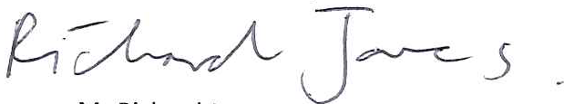
Signature of chair of governors
Review Date | December 2023

Complaints Procedure

1. Introduction
1.1 YSGOL CALON CYMRU is committed to dealing effectively with complaints. We aim to clarify any
issues about which you are not sure. If possible we will put right any mistakes we have made and
we will apologise. We aim to learn from mistakes and use that experience to improve what we do.
1.2 Our definition of a complaint is ’an expression of dissatisfaction in relation to the school or a
member of its staff that requires a response from the school.’
1.3 This complaints procedure supports our commitment and is a way of ensuring that anyone with
an interest in the school can raise a concern, with confidence that it will be heard and, if wellfounded, addressed in an appropriate and timely fashion.
2. When to use this procedure
2.1 When you have a concern or make a complaint we will usually respond in the way we explain
below. Sometimes you might be concerned about matters that are not decided by the school, in
which case we will tell you who to complain to. At other times you may be concerned about
matters that are handled by other procedures, in which case we will explain to you how your
concern will be dealt with.
2.2 If your concern or complaint is about another body as well as the school (for example the local
authority) we will work with them to decide how to handle your concern.
3. Have you asked us yet?
3.1 If you are approaching us for the first time you should give us a chance to respond. If you are
not happy with our response then you may make your complaint using the procedure we describe
below. Most concerns can be settled quickly just by speaking to the relevant person in school,
without the need to use a formal procedure.
4. What we expect from you
4.1 We believe that all complainants have a right to be heard, understood and respected. But
school staff and governors have the same right. We expect you to be polite and courteous. We will
not tolerate aggressive, abusive or unreasonable behaviour. We will also not tolerate unreasonable
demands or unreasonable persistence or vexatious complaining.

5. Our approach to answering your concern or complaint
5.1 We will consider all your concerns and complaints in an open and fair way.
5.2 At all times the school will respect the rights and feelings of those involved and make every
effort to protect confidential information.
5.3 Timescales for dealing with your concerns or complaints may need to be extended following
discussion with you.
5.4 We may ask for advice from the local authority or diocesan authority where appropriate.

5.5 Some types of concern or complaint may raise issues that have to be dealt with in another way
(other than this complaints policy), in which case we will explain why this is so, and will tell you
what steps will be taken.
5.6 The governing body will keep the records of documents used to investigate your concern or
complaint for seven years after it has been dealt with. Records will be kept in school and reviewed
by the governing body after seven years to decide if they need to be kept for longer.
5.7 Complaints that are made anonymously will be recorded but investigation will be at the
discretion of the school depending on the nature of the complaint.
5.8 Where complaints are considered to have been made only to cause harm or offence to
individuals or the school, the governing body will ensure that records are kept of the investigations
that are made and what actions are taken, including the reasons for ‘no action’.
6. Answering your concern or complaint
6.1 The chart in Appendix A shows what may happen when you make a complaint or raise a
concern. There are up to three Stages: A, B and C. Most complaints can be resolved at Stages A or B.
You can bring a relative or companion to support you at any time during the process but you will be
expected to speak for yourself. However, we recognise that when the complainant is a pupil it is
reasonable for the companion to speak on their behalf and/or to advise the pupil.
6.2 As far as possible, your concern or complaint will be dealt with on a confidential basis. However,
there could be occasions when the person dealing with your concern or complaint will need to
consider whether anyone else within the school needs to know about your concern or complaint, so
as to address it appropriately.
6.3 If you are a pupil under 16 and wish to raise a concern or bring a complaint we will ask for your
permission before we involve your parent(s) or carer(s). If you are a pupil under 16 and are involved
in a complaint in any other way, we may ask your parent(s) or carer(s) to become involved and
attend any discussion or interview with you.

Stage A
6.4 If you have a concern, you can often resolve it quickly by talking to a teacher or a member of the
Senior Leadership Team. You should raise your concern as soon as you can; normally we would
expect you to raise your issue within 10 school days of any incident. The longer you leave it the
harder it might be for those involved to deal with it effectively.
6.5 If you are a pupil, you can raise your concerns with your school council representative, form
tutor or a teacher chosen to deal with pupil concerns (as appropriate for the school). This will not
stop you, at a later date, from raising a complaint if you feel that the issue(s) you have raised have
not been dealt with properly.
6.6 We will try to let you know what we have done or are doing about your concern normally within
10 school days, but if this is not possible, we will talk to you and agree a revised timescale with you.
6.7 The person overseeing your concern or complaint will keep you informed of the progress being
made. This person will also keep a log of the concern for future reference.

Stage B
6.8 In most cases, we would expect that your concern is resolved informally. If you feel that your
initial concern has not been dealt with appropriately you should put your complaint in writing to
the headteacher.
6.9 We would expect you to aim to do this within five school days of receiving a response to your
concern as it is in everyone’s interest to resolve a complaint as soon as possible. There is also a
form attached (Appendix B) that you may find useful. If you are a pupil we will explain the form to
you, help you complete it and give you a copy.
6.10 If your complaint is about the headteacher, you should put your complaint in writing to the
chair of governors, addressed to the school, to ask for your complaint to be investigated.
6.11 In all cases, a member of the Senior Leadership Team can help you to put your complaint in
writing if necessary.
6.12 If you are involved in any way with a complaint, a member of the Senior Leadership Team will
explain what will happen and the sort of help that is available to you.
6.13 A member of the Senior Leadership Team will invite you to discuss your complaint at a
meeting. Timescales for dealing with your complaint will be agreed with you. We will aim to have a
meeting with you and to explain what will happen, normally within 10 school days of receiving your
letter. The school’s designated person will complete the investigation and will let you know the
outcome in writing within 10 school days of completion.
Stage C
6.14 It is rare that a complaint will progress any further. However, if you still feel that your
complaint has not been dealt with fairly, you should write, through the school’s address, to the
chair of governors setting out your reasons for asking the governing body’s complaints committee
to consider your complaint. You do not have to write down details of your whole complaint again.
6.15 If you prefer, instead of sending a letter or e-mail, you can talk to the chair of governors or a
member of the Senior Leadership Team who will write down what is discussed and what, in your
own words, would resolve the problem. We would normally expect you to do this within five school
days of receiving the school’s response. You will be asked to read the notes or will have the notes
read back to you and then be asked to sign them as a true record of what was said. We will let you
know how the complaint will be dealt with and will send a letter to confirm this. The complaints
committee will normally have a meeting with you within 15 school days of receiving your letter.
6.16 The letter will also tell you when all the evidence and documentation to be considered by the
complaints committee must be received. Everyone involved will see the evidence and
documentation before the meeting, while ensuring that people’s rights to privacy of information
are protected. The letter will also record what we have agreed with you about when and where the
meeting will take place and what will happen. The timescale may need to be changed, to allow for
the availability of people, the gathering of evidence or seeking advice. In this case, the person
dealing with the complaint will agree a new meeting date with you.
6.17 Normally, in order to deal with the complaint as quickly as possible, the complaints committee
will not reschedule the meeting more than once. If you ask to reschedule the meeting more than
once, the committee may think it reasonable to make a decision on the complaint in your absence
to avoid unnecessary delays.

6.18 We will write to you within 10 school days of the meeting explaining the outcome of the
governing body’s complaints committee’s consideration.
6.19 We will keep records of all conversations and discussions for the purpose of future reference
and review by the full governing body. These records will be kept for a minimum of seven years.
6.20 The governing body’s complaints committee is the final arbiter of complaints.

7. Special circumstances
7.1 Where a complaint is made about any of the following the complaints procedure will be applied
differently.
i. A governor or group of governors
The concern or complaint will be referred to the chair of governors for investigation. The chair
may alternatively delegate the matter to another governor for investigation. Stage B onwards of
the complaints procedure will apply.
ii. The chair of governors or headteacher and chair of governors
The vice chair of governors will be informed and will investigate it or may delegate it to another
governor. Stage B onwards of the complaints procedure will apply.
iii. Both the chair of governors and vice chair of governors
The complaint will be referred to the clerk to the governing body who will inform the chair of the
complaints committee. Stage C of the complaints procedure will then apply.
iv. The whole governing body
The complaint will be referred to the clerk to the governing body who will inform the
headteacher, chair of governors, local authority and, where appropriate, the diocesan authority.
The authorities will usually agree arrangements with the governing body for independent
investigation of the complaint.
v. The headteacher
The concern or complaint will be referred to the chair of governors who will undertake the
investigation or may delegate it to another governor. Stage B onwards of the complaints
procedure will apply.
7.2 In all cases the school and governing body will ensure that complaints are dealt with in an
unbiased, open and fair way.
8. Our commitment to you
8.1 We will take your concerns and complaints seriously and, where we have made mistakes, will
try to learn from them.
8.2 If you need help to make your concerns known we will try and assist you. If you are a young
person and need extra assistance the Welsh Government has established MEIC which is a national
advocacy and advice helpline for children and young people. Advice and support can also be
accessed from the Children’s Commissioner for Wales.
8.3 The governing body has consulted with staff and pupils on this policy and will consult further if
any amendments are made in the future.

MEIC may be contacted by freephone: 0808 802 3456, or text: 84001. This service is operated 24
hours a day.
The Children’s Commissioner for Wales can be contacted by freephone: 0808 801 1000 (Monday to
Friday 9a.m. to 5p.m.), text: 80 800 (start your message with COM) or e-mail:
advice@childcomwales.org.uk

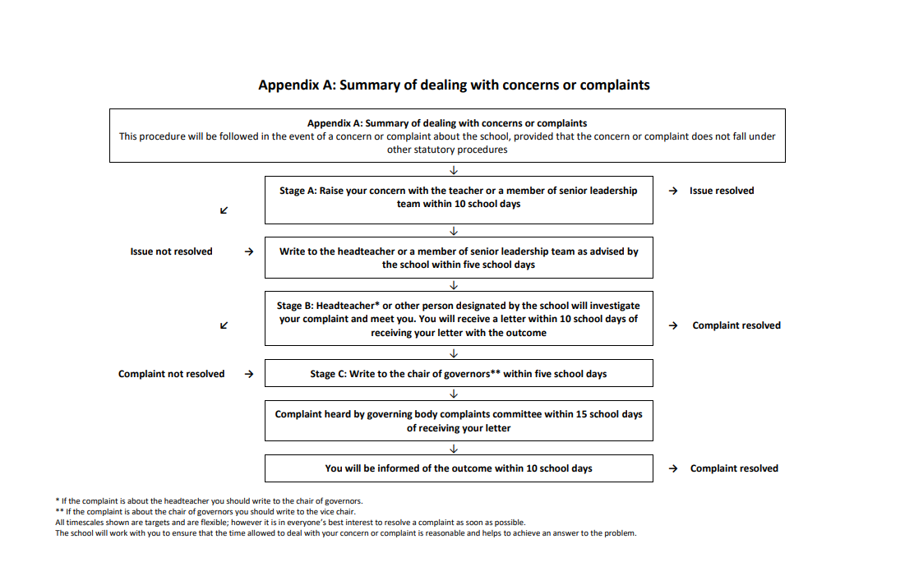

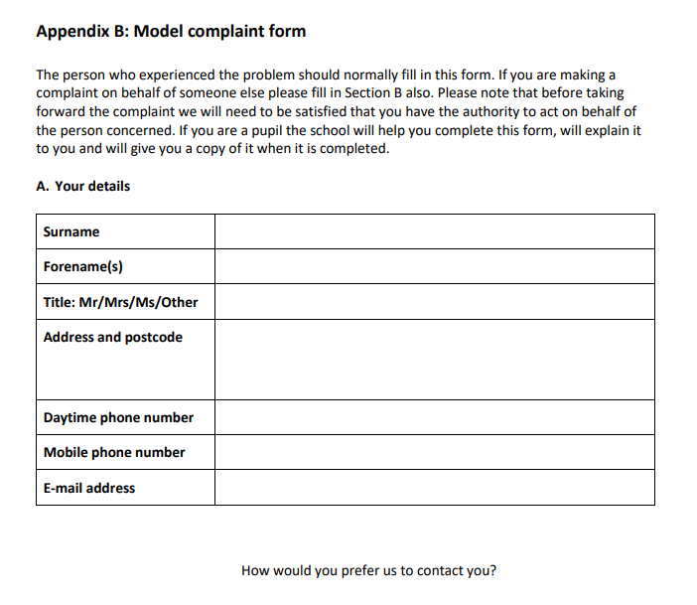

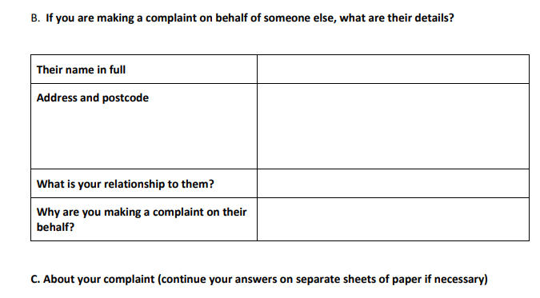
C.1 Name of the school you are complaining about.
C.2 What do you think they did wrong or did not do?
C.3 Describe how you have been affected.
C.4 When did you first become aware of the problem?
C.5 If it is more than three months since you first became aware of the problem, please give the
reason why you have not complained before.
C.6 What do you think should be done to put matters right?
C.7 Have you already put your complaint to a member of staff? If so, please give brief details about
how and when you did so.

