THE SCHOOL AT THE HEART OF WALES

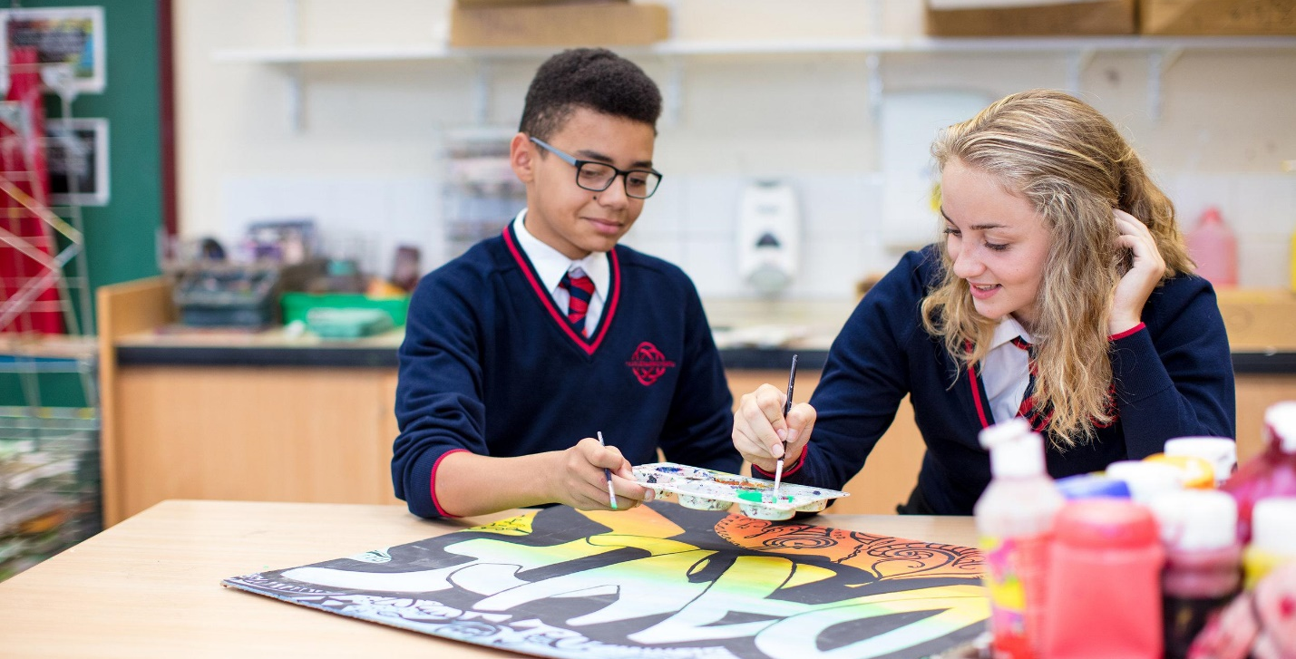

Positive Behaviour Policy

Date adopted | December 2021
Signature of Headteacher | 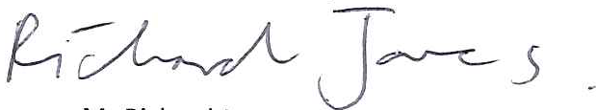
Signature of chair of governors
Review Date | December 2023

Builth Wells Campus  College Rd, Builth Wells, Powys, LD2 3BW  Tel: 01982 553 292 | Llandrindod Wells Campus  Dyffryn Rd, Llandrindod Wells, Powys, LD1 6AW  Tel: 01597 822 992

www.ysgolcalon.cymru
Aims of the Policy
To give all pupils the opportunity to develop as:
• Ambitious, capable learners, ready to learn throughout their lives
• Enterprising, capable learners, ready to play a full part in life and work
• Ethical, informed citizens of Wales and the world
• Healthy, confident individuals, ready to lead fulfilling lives as valued members of society
To create a positive school community where:
• Relationships between staff and pupils are nurtured to avoid negative behaviour (please see school relationships policy https://www.ysgolcalon.cymru/policies)
• Pupils can learn effectively and maximise their potential
• Pupils develop a sense of self-discipline and a responsibility for their own actions
• Restorative practice is used to ensure pupils understand the impact their behaviour has on others (see below)
• Both pupils and staff feel safe, happy, valued and respected
• Good attitudes are nurtured and positive behaviour is praised & recognised
• Both staff and pupils are viewed as positive role models
• A productive atmosphere is created
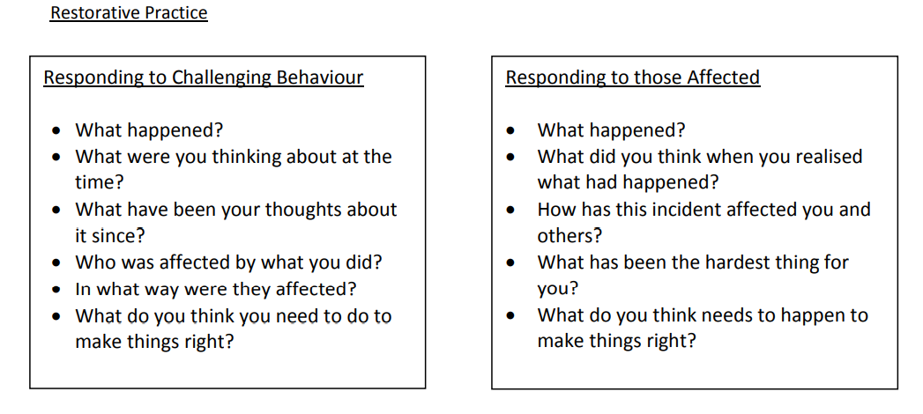
PREVENTING inappropriate behaviour is more effective than reacting to an issue. Staff build positive relationships with their pupils; Duty staff are visible and alert; Staff arrive punctually to the classroom; Staff recognise and praise pupils where appropriate; lessons start positively with no reference made to previous misdemeanours; Attendance is closely monitored.
What is Positive Discipline?
The School believes that positive discipline allows all pupils to make excellent progress and to be successful. It is founded on high expectations and the consistent application by all teachers including recognitions and sanctions.
The positive approach to discipline is preferable to the negative approach: encouragement and praise is more desirable and effective than criticism and punishment.
Roles and responsibilities

The Governing Body
The Governing Body’s Wellbeing Committee is responsible for reviewing and approving the written statement of behaviour principles.
The Governing Body’s Wellbeing Committee will also review this behaviour policy in conjunction with the headteacher and monitor the policy’s effectiveness, holding the headteacher to account for its implementation.

The headteacher
The headteacher is responsible for reviewing this behaviour policy in conjunction with the Governing Body’s Wellbeing Committee. The headteacher will also approve this policy.
The headteacher will ensure that the school environment encourages positive behaviour and that staff deal effectively with poor behaviour, and will monitor how staff implement this policy to ensure rewards and sanctions are applied consistently.

Staff responsibilities
- to model the expectations which we have for our pupils, parents and visitors to school – a respectful, calm and positive working environment where everyone feels valued
- ensure pupils are greeted warmly on entry into school and classrooms and made to feel welcome
- Pupils feel that they are listened to
- Pupils are spoken to calmly and with respect
- Pupils are praised and good work and deeds are recognised and rewarded
- To be fair and consistent in the use of any sanctions
- For any sanction to be explained once – not to argue with pupils over strikes and sanctions
- To ensure that there is no differential application of the policy and procedures on any grounds, particularly ethnic or national origin, culture, religion, gender, disability or sexuality.
- To ensure that the concerns of pupils are listened to and appropriately addressed
Pupil responsibilities
- To uphold the school code of conduct
- To respond positively in and outside of the classroom
- To not disrupt the teaching of a member of staff or learning of other pupils
- To be polite towards all those working or visiting Ysgol Calon Cymru
- To listen to staff and accept decisions without arguing back
- Should a pupil find themselves in a position where they are facing a sanction, they have clear responsibilities to accept the sanction without arguing back
- To complete any sanction
- To work with staff to ensure there is no repeat.
- To take responsibility for their own behaviour
- To ensure that incidents of disruption, violence, bullying and any form of harassment are reported so appropriate action can be taken

Parental responsibilities

- to ensure that their son/daughter is properly equipped and dressed for learning and comes to school with a bag, books, pencil case, calculator etc.
- to take responsibility for the behaviour of their child both inside and outside the school.
- to work in partnership with the school to assist the school in maintaining high standards of behaviour/work ethic/homework
- to raise with the school any issues arising from the operation of the policy

Expectations of pupils
- Show courtesy and respect to all who work at the school as well as visitors
- speak politely to all
- speak respectfully and appropriately in school
- knock on doors and wait to be invited in
- allow adults through doors first
- open doors for people carrying things

2.. Show courtesy, respect and politeness to each other
- walk on the left in corridors in single file
- not run in corridors
- not push each other in corridors
- queue without pushing in front of each other
- respect each others’ property
- act in such a way that behaviour does not cause offence or
embarrassment to others e.g. kissing
- not use abusive, offensive and rude language
- not use threats or bullying behaviour

3.. Be prepared for lessons
- ensure that the necessary books and equipment, planner (where appropriate) and homework are brought for each lesson
- arrive punctually, if lateness is unavoidable, apologise and explain why
- line up outside rooms quietly and in single file
- enter rooms quietly
- get books and equipment out ready as the classroom is entered

4.. During lessons / tutor sessions
- always do their best
- not prevent others from working
- listen to and to do as asked by adults
- complete all work and home study on time
- enter homework clearly in school planner

5. Show respect for school property
- put litter in bins
- recycle when possible
- keep desks free of graffiti
- respect the displays on classroom and corridor walls
- sit on chairs properly without swinging back on them
- keep text books, exercise books and Planners free of graffiti

6. For Assemblies
- enter the Bwyty/Hall/Drama studio in silence
- sit silently and listen attentively

7. During examinations
- be prepared in terms of revision and equipment
- arrive punctually
- ensure that the toilet is visited beforehand
- not communicate with each other
- raise a hand if a teacher’s attention is required
- leave mobiles, bags and coats outside room

8. Use of mobile phones – these are permitted in school but should be switched off during the school day, (the school day begins the moment pupils enter the school site and finishes when they leave the site at the end of the day) so they are not seen or heard. If a phone is seen or heard staff will ask that it is put away if this doesn’t happen staff will confiscate the phone and place it in the school office until the end of the day.

Rewards
Within Ysgol Calon Cymru we firmly believe that a positive approach to behaviour is preferable to a negative approach: encouragement and praise is more desirable and effective than criticism and punishment.
- Reward and recognition are awarded through the Go4Schools system
- Rewards are awarded fairly and for valid reasons – excessive rewards should not be awarded
- Examples of things which could be awarded rewards for – good classwork, homework, representing the school , extra-curricular activities, support for other pupils, support for staff
- Rewards will be age appropriate and respond to pupil voice.

Support

ALN support – this provision provides support for pupils on the ALN register at either School Action, School Action plus or statemented. Please see ALN policy for full details of in class and withdrawn support
Literacy and numeracy support – Extra small group support is provided for pupils with an identified need in numeracy and/or literacy.
ASC ( Based on the Llandrindod Campus) – The Autistic Spectrum Condition support centre provides a base for in class and out of class support for pupils on the Autistic and Aspergers spectrum – please see ASC policy for full details of support offered.
Wellbeing support - provides pupils with support to aid their learning. This support may be through ELSA Thrive, Emotion coaching, intervention and support in lessons, restorative justice, individual behaviour support plans or referrals to outside agencies. For full details of the work of Pastoral support please see the school website, wellbeing pages.
For campus specific details please follow these links
Llandrindod Campus Wellbeing Support
https://www.ysgolcalon.cymru/llandrindod-campus-wellbeing

Builth Campus Wellbeing Support
https://www.ysgolcalon.cymru/builth-wells-wellbeing

Sanctions
For campus specific details please follow this link
https://www.ysgolcalon.cymru/wellbeing
Should pupils fail to respond to good quality teaching and learning experiences and the support offered, they will face the following consequences.
Monitoring and tracking cards
The school will inform parents if their child is to be placed on a monitoring /target card. These may be used for all lessons or specific areas of learning.
Detentions lunchtime/after school
Detentions will vary in length depending on the level and type of negative behaviour.
After school detentions will take place on Monday, Tuesday and Wednesday evenings. The school issues 45 and 90 minute after school detentions. Pupils and parents will be informed by phone of an after school.
Internal exclusion
Should an offence be deemed serious enough, then a pupil may be placed on an internal exclusion. Pupils in internal exclusion will have a different breaktime and lunchtime for the day.
Parents will be expected to attend a meeting with senior staff to discuss the issue. Pupils will be expected to work with Pupil Support to ensure that there is no further repeat of the incident.
Exclusions
In certain circumstances it may be necessary for a fixed term exclusion to be issued – parents and pupils will be informed by letter. Seniors staff/learning co-ordinator will inform parents and pupils of this decision. Parents will be expected to attend a meeting with senior staff to discuss the issue. Pupils will be expected to work with Pupil Support to ensure that there is no further repeat of the incident.
In extreme circumstances it may be necessary for a permanent exclusion to be issued – parents and pupils will be informed by letter. The Headteacher will inform parents and pupils of this decision.
Physical restraint
In some circumstances, staff may use reasonable force to restrain a pupil to prevent them:
- Causing disorder
- Hurting themselves or others
- Damaging property
Incidents of physical restraint must:
- Always be used as a last resort
- Be applied using the minimum amount of force and for the minimum amount of time possible
- Be used in a way that maintains the safety and dignity of all concerned
- Never be used as a form of punishment
- Be recorded and reported to parents

Confiscation
Any prohibited items found in pupils’ possession will be confiscated. These items will not be returned to pupils.
We will also confiscate any item which is harmful or detrimental to school discipline. These items will be returned to pupils after discussion with senior leaders and parents, if appropriate.
Searching and screening pupils is conducted in line with the Welsh Government’s latest guidance on Safe and effective intervention – use of reasonable force and searching for weapons.
Off-site behaviour
Sanctions may be applied where a pupil has misbehaved off-site when representing the school, such as on a school trip or on the bus on the way to or from school.
Malicious allegations
Where a pupil makes an accusation against a member of staff and that accusation is shown to have been malicious, the headteacher will discipline the pupil in accordance with this policy.
Please refer to our safeguarding policy/statement of procedures for dealing with allegations of abuse against staff for more information on responding to allegations of abuse. In accordance with Welsh Government guidance 009/2014: Safeguarding children in education: handling allegations of abuse against teachers and other staff, the headteacher will refer all allegations against teachers and other staff to the Local Authority Safeguarding Officer.
The headteacher will also consider the pastoral needs of staff accused of misconduct.
Training
Our staff are provided with training on managing behaviour, as part of their induction process. Behaviour management will also form part of continuing professional development.
Monitoring arrangements
This behaviour policy will be reviewed by the headteacher and Wellbeing Committee of the Governing Body annually. At each review, the policy will be approved by the headteacher.
The written statement of behaviour principles will be reviewed and approved by the Wellbeing Committee of the Governing Body annually.
Links with other policies
This behaviour policy is linked to the following policies:
- Exclusions policy
- Positive relationships policy
- Safeguarding policy
- Anti-bullying
- ALN

