THE SCHOOL AT THE HEART OF WALES | 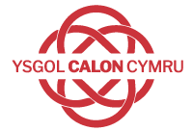

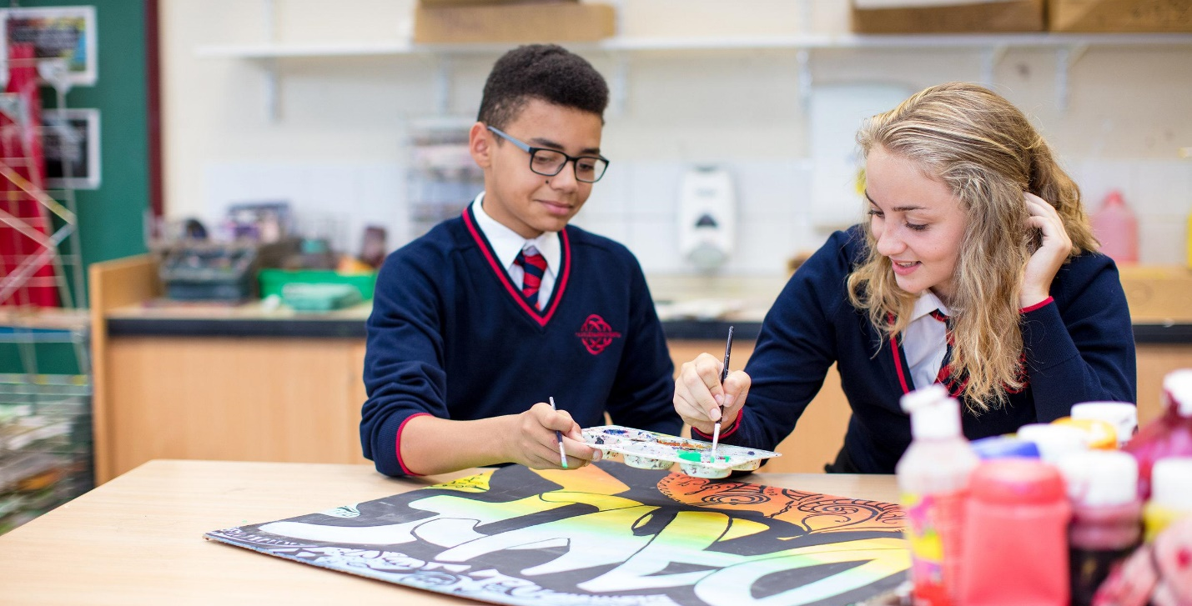

Relationships & Sexuality Education Policy
Dyddiad Mabwysiadu | Rhagfyr 2021
Llofnod y Pennaeth | 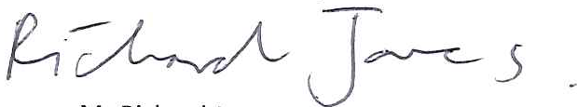
Llofnod Cadeirydd y Llywodraethwyr
Dyddiad Adolygu | December 2022

Builth Wells Campus  College Rd, Builth Wells, Powys, LD2 3BW  Tel: 01982 553 292 | Llandrindod Wells Campus  Dyffryn Rd, Llandrindod Wells, Powys, LD1 6AW  Tel: 01597 822 992

www.ysgolcalon.cymru
Principles & Values
Relationships & Sexuality Education Policy (RSE) refers to our school’s provision that enables our pupils to reach the relevant learning outcomes set out in the Personal and Social Education (PSE) Framework and takes account of Welsh Government guidance published in May 2021. RSE is a positive and protective part of the Curriculum for Wales. It plays a central role in supporting learners’ rights to enjoy fulfilling, healthy and safe relationships throughout their lives. Central to the Curriculum for Wales is an aspiration for every child and young person to achieve the four purposes of the curriculum. A rights and equity based RSE curriculum helps ensure that all learners can develop an understanding of how people’s faith, beliefs, human rights and cultures are related to all aspects of RSE and how these rights can contribute to the freedom, dignity, well-being and safety of all people. Therefore, schools and settings should discuss RSE in the context of the Rights protected by the United Nations Convention on the Rights of the Child. RSE should support learners to develop the knowledge, skills and values to understand how relationships and sexuality shape their own lives and the lives of others. Learners should be equipped and empowered to seek support on issues relating to RSE and to advocate for self and others. RSE will be a mandatory requirement in the Curriculum for Wales for all learners from age 3 to 16 (“the Act”). This means that all learners must receive this education. There is no right to withdraw from RSE in the new curriculum. However, the new curriculum is being phased in, therefore, some pupils may still be withdrawn from RSE pending the new curriculum arrangements being rolled out to their school year.
The law already requires that RSE must be objective, critical, and pluralistic as to its content and manner of teaching. By pluralistic we mean that that where questions of values are concerned, it must not seek to indoctrinate to a particular view but instead should provide a range of views on a given subject. This means that in practice, all schools and settings must teach RSE in a neutral, factual way. Where questions of values arise, we must present learners with different perspectives on a range of views on issues commonly held within society.

Aims
RSE delivery forms a vital link in Ysgol Calon Cymru PSE programme. Specifically, the aims of the RSE programme are:
• to help pupils understand their growth and development, the processes of human reproduction and the nature of sexuality in a diverse 21st century society that includes those who may identify as lesbian, gay, bisexual, trans and queer (LGBTQ++)
• to provide knowledge and understanding of sexual health issues and information about how to obtain appropriate advice on sexual health
• to raise awareness about oneself and the needs and failings of others and develop respect for oneself and others
• to enable pupils to consider the attitudes, values and skills which influence the way they behave and to ensure that pupils are equipped with the knowledge and practical skills to make informed choices in all areas
• to build up pupils’ self-esteem and confidence and equip them with the appropriate skills to manage their relationships in a morally responsible and healthy manner
• pupils can be helped to maintain their emotional and physical health and well-being and know how to keep themselves safe
• as they develop sexually, they need to understand bodily changes, manage sexual feelings and enjoy safe, responsible and happy relationships
• the physical development of pupils depends upon proper nutrition, sufficient exercise, appropriate hygiene, safety and positive healthy choices
• pupils can understand positive health choice and be aware of potential risks of the use and misuse of legal and illegal substances and other poor health choices
• to foster an environment where pupils are taught about building and maintaining respectful relationships. This includes issues relating to bullying and harassment in all its forms, including any related to sexual orientation and sexual relations
• to explore the features of unhealthy relationships including those that feature violence against people, VAWDASV, domestic abuse and sexual violence

Learning Outcomes & Curriculum Design
RSE in the Ysgol Calon Cymru curriculum should give pupils the opportunity to explore a wide range of social, cultural, technological and biological influences that can affect their lives and their ability to form and maintain positive relationships across eight thematic areas:
• Relationships
• Values, rights, culture and sexuality
• Understanding gender
• Violence and staying safe
• Skills for health and well-being;
• Human body and development
• Sexuality and sexual behaviour and
• Sexual and reproductive health
When designing the curriculum for RSE, Ysgol Calon Cymru utilises a developmentally appropriate, rights and gender equity based approach to develop effective provision. Relationships and sexuality education is required to be placed within a clear framework of values and an awareness of the law on sexual behaviour. Features such as family life in all its different forms, including marriage, sexual behaviours, parenthood and sensitive issues such as abortion need to be presented in a balanced way and ethical issues discussed objectively. However, it is equally important to equip pupils to take responsibility for their behaviour in their personal relationships and how to recognise inappropriate behaviour. Pupils should know where and how to access personal information and support. RSE will be taught in PSE and wellbeing sessions, drop down days, in COPE, SWEET, and in Science lessons. There are aspects which are addressed across the curriculum and especially in English, RE, PE, Health & Social Care and Child Development.
The relevant learning outcomes from the PSE framework in KS3 are:
• Be aware of changing relationships in school situations and in the family
• Understand cultural differences and recognise expressions of prejudice and stereotyping
• Know about the different methods of contraception and their effectiveness and know how to use safer sex procedures
• Know the law relating to various aspects of sexual behaviour
• Know how to resolve conflict and negotiate agreement
• Be aware of their character, strengths and weaknesses
• Recognise moral issues and dilemmas in life situations
• Know what they believe to be right and wrong actions and understand the issues involved The relevant learning outcomes from the PSE framework in KS4 are:
• Know how to form supportive and respectful same sex and opposite sex relationships
• Know the importance of the parenting role and the features of effective parenthood
• Recognise and know how to challenge expressions of prejudice and stereotyping
• Understand the risks involved in sexual behaviour which might allow the transmission of sexually transmitted infections including the HIV virus.
The school has a team of Progress Leaders whose task it is to plan and monitor PSE provision ensuring continuity and progression, good use of resources and adequate time allocation. The Progress Leaders are responsible for drawing up a PSE scheme of work which includes RSE. The Progress Leaders with the link member of SLT, monitor the learning, teaching and standards and evaluates the programme. RSE takes place in mixed gender groups but the specific needs of boys and girls will be carefully addressed. Care is also taken to understand the perspectives of pupils from the variety of cultural and religious backgrounds and to cater for pupils of all abilities.
Equal Opportunities
The RSE programme plays an important role within personal effectiveness and personal development at Ysgol Calon Cymru. The school encourages respect for all. The school will therefore not accept any form of prejudice or discrimination, including that on the basis of sexual identity or sexual orientation. Further information can be found in the school’s Equal Opportunities and Anti-Bullying Policies. This publication, takes into account the legal requirements of the 1993 Education Act concerning sex education. All students have equal access and entitlement to the PSE programme regardless of their academic ability, age, sex disability or ethnic background. The school seeks to effectively link learning regarding RSE to the UNCRC where appropriate, the Equality Duty (2010) the Violence against Girls and Women, Domestic Abuse and Sexual Violence Act (2015) and the Well-being of Future Generations (Wales) Act (2015).
Delivery and Content
Ysgol Calon Cymru has a co-ordinated holistic approach towards Personal and Social Education and therefore Relationships and Sexuality Education. RSE is provided through the curriculum. The school’s PSE programme and department’s schemes of work show how opportunities for pupils to reach the relevant learning outcomes are provided. The Wellbeing Assistant Headteachers on both campuses are responsible for developing, monitoring and evaluating the implementation of the programme and supporting staff involved in teaching RSE. The way the curriculum is managed, its organisation and the varying teaching styles are central to the school’s philosophy and ethos. Work to develop this cross-curricular dimension may be included in class or school-based topics. Opportunities for RSE are identified in teachers planning. Alongside PSE lessons and days, topics are led and informed by professionals in their respective fields, such as Police, School Nurses and other appropriate agencies. These and other curriculum areas such as Science, Child Care and Religious Education offer a variety of exciting learning experiences. The Health and Emotional Wellbeing aspect of PSE, considers the pupils’ physical, mental, emotional and sexual development. Within the curriculum content pupils will be taught about:
• Contraception: Teaching about contraception is done in the usual way in a class setting and in an interactive manner. Health and school professionals deliver the sessions and will give information about where pupils can obtain confidential advice and counselling.
• Abortion: When abortion issues are discussed in the school, pupils will be given the opportunity to explore the dilemma, appreciate the validity of opposing views, and develop the communication skills to discuss it with parents and health professionals. The main concern is to reduce the incidence of unwanted pregnancy, and the focus should be on providing appropriate information and effective advice on contraception and the benefits of delaying sexual activity. The religious convictions of pupils and their parents should always be respected.
• Sexual Orientation: Teachers will deal with this issue honestly, sensitively and in a nondiscriminatory way. They will answer appropriate questions and provide factual information. Pupils will be encouraged to respect and recognise diversity and differences in human life and will confirm to guidance and the law from Welsh and Central Governments.
• STIs, including HIV and AIDS: The strategies for teaching about STIs including HIV/AIDS will include helping pupils clarify their knowledge of STIs including HIV/AIDS; teaching them assertiveness skills for negotiating relationships & enabling them to become effective users of services that help prevent/treat STIs and HIV/AIDS. The key components will be factual information and knowledge about safer sex and STIs including HIV/AIDS; an understanding of what is risky behaviour and what is not; condom use and safer sex in general; skills to enable pupils to avoid being pressured into unwanted or unprotected sex, the diagnosis, treatment, and accessing of local sexual health advice services.
Roles and Responsibilities
The Wellbeing Assistant Headteachers are responsible for promoting the Relationships and Sexuality Education programme within the school as well as co-ordinating the PSE programme. This ensures that there is strategic overview of RSE across the school.
Pupils with Special Educational Needs
Some parents and carers of children with special educational needs may find it difficult to accept their children’s developing sexuality. Some pupils will be more vulnerable to abuse and exploitation than their peers, and others may be confused about what is acceptable public behaviour. These children will need help to develop skills to reduce the risks of being abused and exploited, and to learn what sorts of behaviour are and are not acceptable.
External Support
The school uses the advice, support and resources provided by the LA, the local Health Board, and health professionals in the community. Visitors are used in accordance with the LA guidelines on the use of outside agencies in health education. Such visitors complement the teacher and give specialist input e.g. community police officers and school community nurse. Pupils will be given the addresses and contact numbers of clinics and advice centres. including helplines, websites and local advice and sexual health services. Ysgol Calon Cymru ensures that learners know to talk to a trusted adult about any feelings that trouble them and have access to relevant helpline numbers, websites and organisations. The school also benefits from accessing funding from the period poverty grant.
https://gov.wales/its-just-ensuring-girls-period-isnt-barrier-her-succeeding-life

Parents & Pupil Views
It is accepted that the sole responsibility for teaching RSE to young people does not lie with the school. Parents are either the main suppliers of information on this subject, or an important part of the child’s education in most cases, and the school must always work in partnership with the family to achieve the aims laid out here.
Parents are encouraged to support the school’s sex education programme. Information related to the policy will be supplied to parents in the following ways:
• In the School Prospectus and other curriculum guidance materials
• Parents have access, on request, to the package of teaching materials used in sex education lessons by contacting the Progress Leader
There is currently, whilst the new curriculum is being rolled out, a statutory right for parents to withdraw their children from sex education provision, though not from the biologically based information provided in Science lessons. Parents wishing for their child to be withdrawn must contact the Governing Body (i.e. in the first instance, the Headteacher) giving their reasons in writing which must be honoured by the school. YCC will keep a record of such requests. This right remains until the learner attains the age of 19. Reasonable alternative arrangements for learners whose parents/carers have chosen to withdraw them from RSE will be accommodated. The school may be able to offer materials for pupils to use at home. Parents retain the right to withdraw their child from aspects of RSE. A child may be withdrawn from aspects of RSE Workshops during activity days or lessons, but not from the science aspects. Any parent wishing to exercise this right should contact the Head-teacher in writing. Appropriate alternative arrangements will be made for pupils withdrawn from RSE workshops. Parents will be consulted on any proposed significant changes to the school’s RSE policy or provision. Pupil views will be gathered through feedback via learner voice activities.
Practical Arrangements for Girls
Ysgol Calon Cymru makes adequate and sensitive arrangements to help girls cope with menstruation and with requests for sanitary protection. Suitable disposal facilities are provided.
Safeguarding, Child Protection & Confidentiality
Ysgol Calon Cymru operates a Safeguarding Policy that should be read in conjunction with this policy. The issue of pupils’ confidentiality is always stressed as part of the school’s RSE provision. During PSE lessons and days, health professionals or other appropriate external visitors will be involved in delivering RSE workshops, however, they will follow their own professional code of conduct when in their professional role. A teacher will always be present throughout lessons involving an external visitor to enable our pupils with a safe learning environment. Pupils and parents or carers should be made aware of the school’s confidentiality policy, and how it works in practice. Pupils should be informed that teachers cannot offer unconditional confidentiality, particularly in relation to personal disclosures. However, pupils should be reassured that their best interests will be maintained. Pupils should be encouraged, where possible, to talk to their parents or carers about sexual issues. Pupils must be informed of sources of confidential help, for example GP or young persons’ advice service. Ground rules need to be established in lessons. If there is any possibility of abuse the school’s safeguarding & child protection procedures must be followed. All staff, internal or external, must be aware of the procedures involved in the school’s safeguarding policy and the RSE policy. If a teacher is approached by a pupil who is sexually active or contemplating sexual activity, the teacher should:
• Address any safeguarding and child protection issues with the school’s Safeguarding Lead
• Encourage the pupil, wherever possible to talk to the parent or carer
• Take steps to ensure that the pupils has been adequately counselled and informed about contraception, including precise information about where young people can access contraception and advice services. Teachers should also make it clear to the pupil that they cannot guarantee confidentiality in line with the school’s confidentiality policy. The teacher should also ensure that the pupil understands that if confidentiality has to be broken that they will be informed first.
Continuous Professional Development & Professional Learning Opportunities
The training needs of staff involved in the delivery of the RSE programme are identified via continuous professional development interviews and the department’s development plan.
Monitoring and Evaluation
The Wellbeing Assistant Headteachers regularly evaluate the current programme and plan for future developments. The RSE programme forms part of PSE, which is included into the School’s improvement plan. The Progress Leaders and SLT use a variety of methods such as questionnaires and listening to pupils to monitor its performance through Ysgol Calon Cymru’s Self Evaluation Framework.
This policy links to the:
• Personal and Social Education Policy
• Safeguarding Policy
• Positive Behaviour Policy
• Anti-Bullying Policy

Arrangements for Reviewing the Policy
The policy was agreed by the Governors on______________________ and will be reviewed annually in accordance with guidance from Welsh Government.

